CHAPTER 1

PREAMBLE
The preamble comprises of problem statement, solution, objectives, literature review and organization of the report.

1.1 PROBLEM STATEMENT
With rapid urbanization and population growth, waste generation has increased exponentially. Conventional waste management systems rely heavily on manual segregation, which is time-consuming, labor-intensive, and prone to human error. Improper segregation of waste leads to contamination of recyclable materials, environmental pollution, and an overall decline in sanitation and hygiene.
In most developing cities, waste from domestic, industrial, and public sources is collected without proper classification. This results in increased landfill loads, health hazards, and inefficient recycling processes. Manual sorting also exposes workers to hazardous materials and unhygienic conditions.
Furthermore, the lack of real-time monitoring mechanisms results in delayed collection, overflowing bins, and inefficient waste disposal schedules. There is a pressing need for an intelligent system that can automatically detect, classify, and manage waste types to improve efficiency, safety, and sustainability in waste management.

1.2 THE SOLUTION
Our solution addresses as The proposed system, “IoT-Based Smart Waste Segregator”, utilizes sensors and Internet of Things (IoT) technology to automate waste segregation. The system classifies waste into dry, wet, and metallic categories using sensors such as IR sensor, moisture sensor, and metal detector connected to an Arduino Uno microcontroller.
When waste is placed on the segregation platform, the sensors detect its nature — metallic waste triggers the metal sensor, wet waste is identified by the moisture sensor, and dry waste is recognized by the IR sensor. Based on sensor data, servo motors automatically direct the waste into the appropriate bins. The system includes an LCD display to show bin status and uses an ESP8266 Wi-Fi module to send real-time data to a cloud platform or mobile application for monitoring.
Notifications are generated when bins are full, ensuring timely collection and maintenance. This system minimizes human involvement, enhances efficiency, and promotes environmental sustainability by integrating automation and IoT technology in waste management.

1.3 OBJECTIVES OF PROJECT
The main objective of this project is to design and develop an IoT-Based Smart Waste Segregator that automates the segregation and monitoring process to ensure efficient waste management. The specific objectives are:
- To design a system capable of automatically segregating waste into dry, wet, and metallic categories using appropriate sensors.
- To utilize IoT-based communication for real-time monitoring of bin levels and segregation status.
- To provide alerts and notifications when bins are full or when abnormal waste disposal occurs.
- To reduce manual effort and human intervention in waste handling and segregation.
- To ensure eco-friendly waste management by encouraging proper segregation at the source.
- To develop a cost-effective and scalable prototype suitable for both domestic and municipal applications.

1.4 ADVANTAGES

The proposed system offers several advantages over traditional waste management methods:
- Automation: Minimizes manual labor by automatically segregating waste.
- Efficiency: Reduces time and effort required for waste sorting.
- Accuracy: Improves segregation precision using multiple sensors.
- Smart Monitoring: Enables remote bin monitoring through IoT connectivity.
- Environmental Benefits: Promotes recycling and minimizes pollution.
- Health and Safety: Reduces exposure of workers to harmful waste materials.
- Scalability: Suitable for residential, commercial, and public use cases.
- Data Tracking: Enables data-driven decision-making for waste collection and logistics.

1.5 LITERATURE SURVEY

[1] S. Venkatesh , G. Pradeep , M. Jayanthi , Dr. P. Suresh , S. Muthurajkumar “Smart Garbage Segregation & Management System Using IoT & ML” May 2021(Published : Proceedings, Volume 45, Part 7, 2021)

The paper presents an integrated system that addresses urban waste management challenges using

IoT and Machine Learning. The key objectives are:

Automated Garbage Classification: Leveraging sensors and a convolutional neural network (CNN) model to distinguish between biodegradable and non-biodegradable waste.

Real-Time Monitoring: Use of IoT-enabled smart bins to track waste levels and optimize waste collection schedules.

Data Analytics: Collection and processing of data for better decision-making and future prediction of waste trends.

Environmental Benefit: Reducing manual labor, improving efficiency in garbage segregation, and contributing to cleaner surroundings.

The system aims to reduce human intervention, promote smart city infrastructure, and make

garbage disposal more intelligent and sustainable.

[2] Priyanka Bhatele , Tejas Mali , Manas Dalvi , Manthan Manalwar , Manas Kulkarni , Aman

Manakshe (All affiliated with Vishwakarma Institute of Technology, Pune, India) “Smart Waste Segregation Using IoT” May 26–28, 2023 (Presented at the 2023 4th International Conference for Emerging Technology (INCET), Belgaum, India)

This project proposes a low-cost, sensor-driven smart bin system capable of automatically

segregating waste into three categories: dry, wet, and metallic. Key features include:

Sensor-Based Detection:

Inductive Proximity Sensor for metals

Moisture Sensor for wet waste

Ultrasonic Sensor for dry waste and bin fill levels
- Automation: Uses Arduino UNO to control sensor inputs and servo motors for mechanical sorting.
- Working Mechanism: Waste is placed on a lid where sensors detect its type and direct it to the corresponding internal bin.
- LCD Notifications: Alerts when a bin is full.
Result: The prototype achieved waste classification accuracy of around 90–93% for different types of objects.

[3] Mary P. Varghese , V.S. Anooja , R. Akhila , M. Krishnakumar , Arun Xavier (All affiliated

with Vidya Academy of Science & Technology, Thrissur, India) “IoT-Based Smart Waste

Management System with Level Indicators for Effective Garbage Waste Segregation” 2024

(Presented at the Third International Conference on Distributed Computing and Electrical Circuits and Electronics (ICDCECE))
This paper proposes an IoT-enabled Smart Waste Management (SWM) system featuring real-time
level indicators in garbage bins. Key features include:
- Sensor-Equipped Bins: Measure and transmit fill levels using LoRa-based sensors.
- Garbage Segregation: Bins are compartmentalized to separate dry and wet waste.
- Visual Feedback: LED indicators signal bin status (green/yellow/red) for real-time alerts.
- Smart Control: A Raspberry Pi and NodeMCU coordinate sensors, GPS, and camera inputs to analyze and sort waste (organic/inorganic).
- Cloud Connectivity: Data is transmitted through gateways to centralized monitoring systems for efficient scheduling.
Conclusion: The system improves municipal waste operations by optimizing collection, enhancing segregation, and reducing environmental impact, aligning with sustainability goals.
[4] Mohinish Paturi ,Sampath Puvvada , Badhari Sai Ponnuru ,Mounika Simhadri , Bhaskara S.
Egala , Ashok Kumar Pradhan (All affiliated with the Department of Computer Science, SRM University, AP) “Smart Solid Waste Management System Using Blockchain and IoT for Smart Cities” 2021 (Presented at the 2021 IEEE International Symposium on Smart
Electronic Systems (iSES))
This paper proposes an innovative smart waste management system that leverages Blockchain and IoT to address issues in urban solid waste handling. The main contributions are:
  - IoT-Enabled Smart Bins: These bins identify and record the type and weight of waste.
  - Blockchain-Based Reward Distribution: Citizens are rewarded for correct waste disposal using smart contracts and cryptocurrency tokens.
  - Smart Contracts: Automatically validate user input and trigger reward distribution without manual intervention.
  - Network Comparison: The system was tested on Ethereum Ropsten, Binance Smart Chain (BSC), and Polygon (Matic), with Matic performing best in terms of speed and cost (gas fee).
  - Transparency and Security: Blockchain ensures immutable transaction logs and eliminates single points of failure.
Conclusion: The integration of IoT and blockchain fosters an accountable and incentivized waste management system ideal for smart cities, promoting user participation and waste segregation through tangible rewards.
[5] Gregory Davrazos , Theodor Panagiotakopoulos , Sotiris Kotsiantis , Achilles Kameas
(Affiliated with the University of Patras, Hellenic Open University, and University of Nicosia)
“Predicting Cost of Municipal Waste Management using IoT Data and Machine Learning”
2023 (Presented at the 14th International Conference on Information, Intelligence, Systems &
Applications – IISA 2023)
This research focuses on predicting the cost of municipal waste management by analyzing IoTcollected data with machine learning techniques. Key elements:
- Dataset: Public dataset with over 30 features (e.g., population, altitude, waste types, revenue, area).
- Models Used: CatBoost, Extra Trees, LightGBM, XGBoost, Random Forest, and others.
- Best Model: CatBoost Regressor, slightly outperformed by a Soft Voting Ensemble combining top models.
- Evaluation Metrics: MAE, MSE, RMSE, R², RMSLE, MAPE.
Result: The ensemble model achieved the best overall predictive performance for municipal cost estimation.
Implication: Helps municipal authorities optimize budget planning and waste operations through data-driven insights.
[6] Pranav A. Patil , Nikhil B. Patil , Chaitanya G. Patil , Prof. S. A. Patil “Smart Garbage
Segregation & Management System Using Internet of Things (IoT) & Machine Learning
(ML)" May 2023
The paper does not mention a specific formal survey title. However, it references the
implementation and evaluation of a smart waste management system using IoT and ML
technologies.
The study proposes a smart garbage segregation and management system that uses:
- IoT-based sensors to detect the level of garbage in bins and classify waste.
- Machine Learning (ML) algorithms to identify and sort dry and wet waste.
- A camera and ultrasonic sensor setup for accurate waste detection and classification.
- An automatic notification system that alerts municipal authorities when bins are full. The goal is to improve hygiene, enhance waste sorting efficiency, reduce human intervention, and facilitate better municipal waste handling.
[7] A.A. Popov , A.O. Kuzmina , “Justification of the Common Information Space Components for the Solid Waste Management” 2018 (Published under IEEE, as indicated by the line: "©2018 IEEE")
The article discusses the creation of a Common Information Space (CIS) to improve municipal solid waste management in the Russian Federation. Currently, waste-related data is fragmented across various organizations, making effective decision-making and processing difficult. The proposed system aims to integrate data from activities like collection, transportation, sorting, processing, dumping, and consumption of solid waste into a unified information structure.
The authors present:
- A parametric model with arrays and matrices that capture various stages and entities involved in waste management.
- A set of software modules necessary for data collection, document processing, forecasting, and analysis.
- Algorithms to minimize waste dumping through optimal distribution of waste and its by-products across different organizations.
The system promotes data transparency, inter-organization collaboration, and efficient solid waste handling across municipalities and regions, with the ultimate goal of reducing environmental impact and improving resource reuse.

[8] Anushree Shetty , Shambhavi , Shreya Shetty , Raghavendra U, “Comprehensive Study of

Distinctive Methods of Waste Segregation and Management” May 2023

The project presents a comprehensive analysis of various methods for waste segregation and

management, aiming to address the environmental issues caused by improper waste disposal. It
highlights the need for effective segregation of biodegradable and non-biodegradable waste to
improve recycling, reduce environmental pollution, and enhance public health.
The paper explores both manual and automated approaches to waste management, including smart bin technologies, IoT-based systems, and sensor-based segregation. It compares these methods in terms of effectiveness, affordability, and practicality in real-world applications.
The study concludes with a call for increased awareness, better infrastructure, and integration of smart technologies to ensure efficient and sustainable waste management practices in urban and rural settings..
[9] Shamin N , P. Mohamed Fathimal , Raghavendran R , Kamalesh Prakash “Smart Garbage Segregation & Management System Using Internet of Things (IoT) & Machine Learning (ML)” 2021 (Presented as part of IEEE publication)
This paper presents a smart garbage segregation and management system that integrates Internet of Things (IoT) and Machine Learning (ML) technologies. The proposed system aims to improve waste management efficiency by automating the process of waste detection, classification, and data transmission in real-time.
Key features of the system include:
- Ultrasonic sensors to detect the presence of waste.
- Moisture sensors to differentiate between wet and dry waste.
- Metal sensors for detecting metallic items.
Image processing and machine learning (SURF & KNN algorithms) to classify degradable and non-degradable waste.
Real-time data upload to the cloud for centralized monitoring.
The system achieved 99% accuracy under good lighting conditions and emphasizes reducing manual intervention in waste segregation, especially important during health crises like the COVID-19 pandemic.
[10] Eyhab Al-Masri , Ibrahim Diabate , Richa Jain , Ming Hoi Lam , Swetha Reddy Nathala “An IoT-Enabled Framework for Urban Waste Management” 2018 (Presented at the IEEE International Conference on Big Data)
The paper introduces Recycle.io, a smart and IoT-enabled waste management system designed to detect violations at the time of waste disposal. The system is tailored for urban and smart city environments, aiming to reduce costs, improve regulation enforcement, and enhance the efficiency of waste management processes.
Key features include:
- Smart bins equipped with ultrasonic sensors and cameras that detect and classify waste.
- Use of edge computing (via Raspberry Pi) to process data locally before transmitting essential information to the cloud.
- Integration with Microsoft Azure IoT Hub for device management, real-time monitoring, and data analytics.
- Violation detection (e.g., placing non-recyclables in recycling bins) using machine learning and image classification models.
A cloud dashboard providing real-time visual insights and geographic tracking of waste collection violations.
The system reduces latency, bandwidth use, and costs, while providing a scalable and efficient platform to support sustainable waste management.
[11] A.O. Kuzmina , A.A.Popov ”Justification of the Common Information Space Components for the Solid Waste Management” 2018 (IEEE Publication)
This paper addresses the inefficiencies in solid waste management (SWM) within the Russian Federation, particularly the fragmented nature of data collection, processing, and storage among different enterprises. The authors propose the creation of a Common Information Space (CIS) to integrate data related to all phases of SWM — collection, transportation, sorting, processing, dumping, and consumption.
Key contributions include:
- A parametric model that defines how data should flow and be processed within the CIS.
- A comprehensive data structure using arrays and matrices to represent organizational roles, types of waste, quantities, and document records.
- A set of software modules required to implement the CIS, ensuring seamless interaction between waste management stakeholders and real-time decision-making.
- Optimization algorithms for minimizing the amount of dumped waste by improving distribution and usage of processed materials.
The paper concludes that CIS can lead to more efficient, transparent, and cost-effective solid waste management by supporting unified data access and decision support across organizations and government bodies.
[12] Prof. Ashok K N , Ms. Nagashree C R , Ms. Kavyashree K S , Ms. Navya L , Ms. Keerthana S “Tracking Waste Disposal and Generation of Fine to Control and Promote Proper Waste Segregation” 2024 (Presented at the 2024 IEEE International Conference on Knowledge Engineering and Communication Systems - ICKECS)
This project addresses India’s growing urban waste issue by introducing a technological solution to encourage proper waste segregation and penalize non-compliance. The proposed system uses Convolutional Neural Networks (CNNs) and image processing to detect whether waste is correctly segregated into biodegradable and non-biodegradable categories.
Key Features:
- Image-based analysis using CNN to classify waste captured via webcam.
- Dataset: Over 256,000 images sourced from Kaggle, divided into two categories — biodegradable (e.g., food, plants, fruits) and non-biodegradable (e.g., plastics, metals).
- Model Training: Includes preprocessing, augmentation, and deep CNN layers for feature extraction and classification.
- Fine Generation Mechanism: A fine is imposed if more than 5% of the waste in an image is misclassified as non-biodegradable, calculated at ₹2 per percentage point.
- Results Display: System displays output including classification results and imposed fines, promoting transparency and awareness.
- Technologies Used: TensorFlow, Keras, OpenCV, Matplotlib, Tkinter.
The system provides a smart, automated, and accountable approach to urban waste management. It encourages individuals and institutions to improve waste segregation habits by blending machine learning with civic enforcement, ultimately contributing to environmental sustainability.
[13] Shravya Chepa , Aashish Sharma , Shivani Singh , Santosh Naik , Himanish Dutt , Hema Mahajan “A Comprehensive Study of Distinctive Methods of Waste Segregation and Management” 2021 (Presented at the Third International Sustainability and Resilience Conference: Climate Change, IEEE)
This research paper explores modern methods of waste segregation and management using emerging technologies like IoT (Internet of Things) and deep learning. The authors emphasize that improper waste disposal practices lead to severe environmental and health problems and propose automation as a solution.
Key Concepts and Methods:
- IoT-enabled systems such as smart bins that notify waste levels and assist in timely collection.
- Deep Learning models like YOLO and CNNs used to detect and classify waste types (e.g., plastic, metal, organic).
- Mechanical segregation systems, including conveyor belts, rotating bins, and robotic arms integrated with sensors (IR, moisture, proximity).
- Portable and programmable waste monitoring systems that automate classification, data logging, and alerts.
The paper advocates for integrating technology to minimize human intervention in waste handling, especially beneficial during health crises like pandemics. It argues that these solutions, when implemented at scale, can enhance efficiency, reduce environmental impact, and foster sustainable urban development.
[14] M. Krishnakumar ,Arun Xavier, Mary P. Varghese , V.S. Anooja , R. Akhila “IoT-Based Smart Waste Management System with Level Indicators for Effective Garbage Waste Segregation” 2024 (Presented at the Third International Conference on Distributed Computing and Electrical Circuits and Electronics (ICDCECE), IEEE)
This paper proposes a smart waste management system that leverages IoT technology to enhance the efficiency and sustainability of garbage segregation and collection processes. The system integrates smart bins with sensor nodes and level indicators, which help monitor waste levels in real-time and improve garbage classification at the source.
Key Features:
- IoT-enabled smart bins equipped with sensors to track fill levels and types of waste (dry, wet, organic, inorganic).
- Level indicators (LEDs) visually and digitally signal the waste status (low, nearing full, full).
- Real-time data is sent via LoRa communication modules to a central server, allowing for optimized route planning and collection scheduling.
- A Raspberry Pi controller and NodeMCU microcontroller work together for image-based classification and control of waste bin compartments.
- Integration of GPS modules helps track bin locations.
Benefits:
- Reduces overflow and unsanitary conditions.
- Enables accurate and timely waste collection.
- Encourages better segregation practices, aiding recycling.
- Supports smart city infrastructure and environmental sustainability goals.
[15] Manas Dalvi , Manthan Manalwar , Manas Kulkarni , Priyanka Bhatele , Tejas Mali Aman Manakshe “Smart Waste Segregation Using IoT” 2023 (4th International Conference for Emerging Technology (INCET), Belgaum, India)
This paper introduces an automated IoT-based waste segregation system aimed at addressing the inefficiencies in traditional waste disposal methods. The focus is on categorizing household waste into metallic, wet, and dry categories at the point of disposal using smart sensors and Arduino-based automation.
Key Components and Functionality:
- Inductive Proximity Sensor: Detects metallic waste.
- Soil Moisture Sensor: Identifies wet waste by measuring moisture content.
- Ultrasonic Sensor: Determines proximity and fullness of bins, and identifies dry waste.
- Servo Motors: Rotate bins or lids to deposit waste in the correct container.
- LCD Module: Displays real-time bin status alerts.
The system uses an Arduino Uno microcontroller to control sensor operations and motor movements. Waste is sorted in a priority order—first as metallic, then wet, and finally dry—based on sensor readings.
- The prototype demonstrated 90–93% accuracy across all categories.
- It successfully sorted items like tin cans, banana peels, wet tissues, and paper.
- Messages about bin status (full/empty) were accurately displayed on the LCD screen.
- Integration with GSM and Bluetooth for alert notifications.
- Use of solar energy for sustainable operation.
- Possible deployment in public spaces, corporate parks, and municipal zones.
[16] Neil Alexander G. Macasaet , Elidad Rachel R. Martinez , Ernesto M. Vergara Jr , “Automatic Segregation of Limited Wastes through Tiny YOLOv3 Algorithm”Presented at the 13th International Conference on Computing, Communication, and Networking Technologies (ICCCNT) held virtually from October 3-5, 2022.
The paper introduces an automated waste segregation device leveraging the Tiny YOLOv3 algorithm implemented on a Raspberry Pi 4B. It aims to enhance proper waste management practices by detecting, classifying, and segregating waste into biodegradable and non-biodegradable categories. The system uses a pre-trained Tiny YOLOv3 model with a COCO dataset. It achieved an overall detection and classification accuracy of 88% and a waste segregation accuracy of 100%.
Key findings include:
- Precision, recall, and F1 scores for classification: 100%, 88%, and 93%, respectively.
- Demonstrated a real-time waste segregation device with a single input limitation.
- Identified challenges with the accuracy of biodegradable waste detection and recommended further training with specific datasets to improve performance.
[17] Rubina Dutta , Deepti Prit Kaur , Jeetasha , Priyanka Malhotra , Harsimran Jit Kaur , “Sort-O-Matic: An Efficient Waste Segregation System for Sustainable Waste Management” Presented at the 4th International Conference on Data Analytics for Business and Industry (ICDABI), 2023.
This study introduces "Sort-O-Matic," an autonomous system designed to improve waste segregation using sensors and automation. The project aims to enhance sustainable waste management by classifying waste into three categories: dry, wet, and metallic, using a combination of sensors such as metal detection sensors, moisture sensors, infrared sensors, and ultrasonic sensors.
System Architecture:
- The system follows a Sense-Think-Act paradigm.
- Sensors detect the type of waste, analyze it using an Arduino Uno microcontroller, and sort it into designated bins.
- It employs a conveyor belt mechanism powered by a motor for waste transportation.
Performance Metrics:
- Achieved 95% accuracy in segregating waste.
- Dual checking mechanisms enhance reliability for classifying waste.
- Moisture sensor detects wet waste with approximately 80% accuracy.
Benefits:
- Reduces human intervention in waste segregation.
- Alerts authorities when bins are full via an ultrasonic sensor.
Challenges and Limitations:
- Calibration of sensors, especially the metal detection sensor, required frequent adjustments.
- Could only process one waste item at a time and struggled with mixed waste.
Future Enhancements:
- Integration with IoT for real-time monitoring and alerts.
- Potential use of artificial intelligence and machine learning for better waste categorization.
[18] Santhosh Kumar B. R , Rohit K , Varalakshmi N , Manjunath , Soundarya S. Lokeshwari , Sahana D. N , “Eco-Friendly IoT-Based Waste Segregation and Management”Presented at the 2017 International Conference on Electrical, Electronics, Communication, Computer and Optimization Techniques (ICEECCOT), 2017.
The study presents an innovative approach for waste segregation and management at the domestic level, leveraging IoT and sensor technologies. It proposes an automated system capable of segregating waste into biodegradable, metallic, and plastic categories using various sensors such as moisture, inductive, capacitive, gas, and bacteria sensors. The primary objectives are to address inefficiencies in waste management, reduce environmental impact, and promote recycling.
System Overview:
- Sensors detect waste type and segregate it into respective compartments.
- Biodegradable waste is treated chemically to control microbial activity and mitigate odors using gas sensors and odor controllers.
- IoT integration provides real-time monitoring and alerts when bins reach capacity.
Implementation Details:
- The system uses an STM32 microcontroller to coordinate sensor data and perform segregation.
- Waste levels are monitored using level-detecting sensors, and alerts are sent via Wi-Fi to inform users when bins are full.
Advantages:
- Hygienic and efficient segregation at the source level reduces human interaction and environmental pollution.
- Each bin segment is detachable for convenient disposal and recycling.
Future Enhancements:
- Additional capabilities include improved sensor accuracy, better integration with smart systems, and optimization of chemical treatments for biodegradable waste
[19] S. Menaka , A. Gayathri , “To Improving the Performance of Identification and Segregation of Liquid and Solid from Municipal Waste Using Adam Optimization Algorithm” Presented at the International Conference on Self Sustainable Artificial Intelligence Systems (ICSSAS) 2023.
This paper focuses on enhancing the efficiency of waste identification and segregation processes using the Adam optimization algorithm. The goal is to improve the recycling of liquid and solid waste by leveraging advanced machine learning techniques, particularly deep learning models like CNNs (Convolutional Neural Networks).
Algorithm Implementation:
- The Adam optimization algorithm is used to train models on datasets comprising waste samples.
- Features such as color, texture, and composition are analyzed to accurately classify liquid and solid waste.
Benefits of Approach:
- Resource Recovery: Enables the efficient extraction and reuse of valuable materials from solid waste.
- Environmental Protection: Proper segregation reduces contamination and prevents harm to ecosystem
System Design:
- Data collection and preprocessing involve creating labeled datasets of liquid and solid waste samples.
- Features are extracted to train a CNN model, and the Adam optimizer ensures high accuracy and efficient training.
Applications and Outcomes:
- The model achieved improved segregation accuracy, enhancing the quality of recyclables and operational efficiency.
- Real-world deployment includes automatic waste sorting based on predictions.
Challenges and Future Scope:
- Balancing data classes and addressing mixed waste streams require further advancements.
- Integration with IoT and development of advanced recycling technologies are suggested for broader adoption.
[20] Shashank Shetty , Sanket Salvi , “SAF-Sutra: A Prototype of Remote Smart Waste Segregation and Garbage Level Monitoring System” Presented at the International Conference on Communication and Signal Processing, July 28–30, 2020.
The "SAF-Sutra" project introduces a low-cost, modular waste segregation and monitoring system, leveraging IoT and cloud technologies. The system aims to address inefficiencies in waste management through automation and remote monitoring, targeting household and community-level applications.
System Design:
- The project integrates sensors and actuators for waste segregation based on properties such as moisture content and metal detection.
- Uses a conveyor belt mechanism to route waste into three categories: metallic, wet, and dry waste.
- Includes a garbage level monitoring subsystem, which tracks bin levels and updates them to the cloud.
Technological Implementation:
- MSP430 microcontroller and NodeMCU handle sensor data and system control.
- Cloud-based monitoring via ThingSpeak allows real-time tracking and notifications when bins reach capacity.
- Components like moisture sensors, rain sensors, and ultrasonic sensors optimize waste identification.
Results and Advantages:
- Achieves cost-efficiency by utilizing PVC pipes and off-the-shelf components.
- Modular design ensures ease of portability and assembly.
- Enables remote monitoring via a mobile application linked to cloud data.
Applications and Future Enhancements:
- Ideal for household and community waste management, with potential to scale for industrial use.
- Future developments include adding sensors for plastic and glass segregation, automated waste collection trucks, and improved notification systems
[21] Md Jiabul Hoque , Md Emdadul Hoque Bhuiyan , Sanzid Hossain Tayef , Md. Razu Ahmed , Abdullah Al Noman , Md. Abdul Kader Zilani “An IoT-Based Smart Waste Management System for Efficient Waste Segregation and Collection” Published Date: Presented at the 2024 4th International Conference on Innovations in Science, Engineering, and Technology (ICISET), October 26–27, 2024, Chittagong, Bangladesh.
This paper introduces an IoT-based smart waste management system designed to improve waste segregation, optimize collection processes, and reduce the environmental impact of traditional methods. The system integrates real-time monitoring, automated segregation, and cloud-based data management to enhance efficiency and sustainability.
System Components:
- Automated Waste Segregation: Uses sensors such as infrared, inductive proximity, and capacitive proximity to classify waste into metal, plastic, and organic categories.
- Real-Time Monitoring: Ultrasonic sensors track bin fill levels, triggering alerts at 90% capacity.
- Cloud Connectivity: Data is uploaded to a cloud platform (Thingspeak), enabling remote monitoring and analysis.
Technological Innovations:
- Automated conveyor belt and sensor integration streamline waste identification and sorting.
- Cloud-based storage and notifications facilitate route optimization and timely waste collection.
Performance:
- Metal detection: 83.33% accuracy
- Plastic detection: 75% accuracy
- Organic waste detection: 91.66% accuracy
Benefits:
- Reduces collection frequency and fuel consumption.
- Prevents bin overflow and environmental pollution.
- Promotes recycling and sustainable waste disposal practices.
Future Scope:
- Enhanced sensor accuracy and integration of machine learning for better waste categorization.
- Addressing scalability, maintenance, and security challenges.
[22] Rasha Kashaf , Edwin P. Alegre , Tasnim Prova , Sakshi Aggarwal , “Automated Waste Management Using a Customized Vision-Based Transformer Model” Presented at the 2024 IEEE World AI IoT Congress (AIIoT), 2024.
The paper presents an innovative approach to waste management using a customized Vision Transformer (ViT-WM) model. The study focuses on leveraging advanced deep learning techniques for automated waste classification and segregation, aiming to enhance urban sustainability within smart city frameworks.
Customized ViT-WM Model:
- Utilizes Vision Transformers (ViT) for precise waste classification.
- Achieved a classification accuracy of 98.17% with a loss value of 0.0793 after training on an enhanced dataset.
Dataset Enhancement:
Combines existing datasets (TrashNet and Kaggle datasets) to create "TrashNet Enhanced" with over 19,800 images categorized into seven classes: biodegradable, cardboard, glass, metal, paper, plastic, and trash.
Innovative Methodology:
- Employs patch-based image segmentation and positional encoding.
- Integrates multi-head attention mechanisms for better contextual understanding of image data.
Applications and Impacts:
- Supports automated sorting systems integrated with IoT devices for waste management in smart cities.
- Facilitates improved recycling processes and reduces landfill waste.
Future Scope:
- Expand model adaptability to handle more waste types and complex urban waste streams.
- ncorporate multi-label classification capabilities and address cybersecurity concerns in IoT integrations.
[23] P. Santhuja , Dr. Suresh A , “CNN-Based Circular Economy in E-Waste Management with Blockchain and IoT Integration”Presented at the International Conference on Visual Analytics and Data Visualization (ICVADV), 2025.
This paper introduces an integrated approach to e-waste management combining Convolutional Neural Networks (CNNs), IoT-enabled real-time monitoring, and Blockchain-based secure traceability. The system aligns with the principles of the circular economy by enhancing e-waste recycling and resource recovery.
Automated Waste Classification:
- The CNN model trained on the E-WasteNet dataset (50,000 images) categorizes e-waste into recyclables, reusables, and hazardous items.
- Achieved 96.2% classification accuracy, reducing misclassification errors by 19%.
IoT Integration:
- IoT sensors and RFID tags enable real-time monitoring of e-waste bins, tracking weight, composition, and hazardous materials.
- Data is transmitted using LoRaWAN and 5G technologies to cloud platforms for analysis.
Blockchain for Traceability:
- Ensures secure and transparent tracking of e-waste transactions using tamper-proof digital IDs
- Smart contracts automate compliance checks, reducing fraud and illegal disposal.
Performance Improvements:
- Reduced sorting errors by 28% and increased sorting efficiency by 32%.
- Enhanced resource recovery rates by 23%, focusing on valuable components like gold, copper, and lithium.
System Architecture:
- Combines intelligent waste collection, IoT-driven monitoring, CNN-based classification, and Blockchain-secured traceability for a sustainable e-waste management system.
[24] M. Bhuvaneswari , K. Tansin , S. Tazmeel Ahamed , N. Tharun Sri Ram , S. Venu Prasath
“Internet of Things-Based Intelligent Waste Segregation and Management System for
Smart Home Application” Presented at the 7th International Conference on Communication and Electronics Systems (ICCES), 2022.
This paper proposes an IoT-enabled smart waste segregation and management system tailored for smart home applications. The system leverages sensors, microcontrollers, and IoT communication modules to enhance waste sorting and disposal efficiency.
System Design:
- The system uses sensors such as inductive proximity sensors, temperature and humidity sensors, and ultrasonic sensors to detect and classify waste into metal, wet, and dry categories.
- A microcontroller (Arduino UNO) and a Node MCU handle real-time monitoring and data communication.
IoT Integration:
- IoT communication modules enable centralized monitoring and data transmission to municipal offices.
- A mobile application provides users with bin status updates.
Automated Segregation:
- Waste is analyzed and segregated using a stepper motor-controlled turntable mechanism.
- The system alerts users and municipal authorities when bins are full, ensuring timely waste collection.
Results:
- High accuracy in identifying and segregating different types of waste.
- Reduced human intervention in waste management.
Future Enhancements:
- Incorporation of mechanisms for crushing and drying waste to simplify recycling.
- Integration with smart home systems for automated operations.
[25] D.A. Janeera, Pratheeba R, Shreemathi V, Ragamaliga M, M. Sahaya Sheela “Visual Servoing and Deep Capsule Network Learning for Contactless Smart Waste Segregation": 2021. This paper addresses the issue of inefficient and unsafe waste segregation systems, which are critical due to urbanization and industrialization. The authors propose a smart, contactless waste segregation model that utilizes visual servoing, deep capsule network learning, and various sensors. This system categorizes waste into degradable, non-degradable, and radioactive materials ensuring safe handling and reducing human health risks. The model integrates traditional CNN with capsule networks to improve classification accuracy (98.2%) and energy efficiency (95%). The proposed system combines sensor-based and visionbased _ technologies for optimal performance. It identifies waste using sensors like capacitive. inductive, and ionizing sensors, while unrecognized waste is processed through an AI-based image classification system. The system has applications in hospitals, public areas, and industries emphasizing eco-friendliness, cost-efficiency, and adaptability for future enhancements. 21 This work was presented at the Second International Conference on Smart Electronics and Communication (COSEC) and emphasizes its significance in achieving sustainable Waste management.

The above literature reveals significant research interest in automated and intelligent waste management. However, most existing systems are either limited in scalability or lack real-time communication. The proposed system combines cost-effectiveness, IoT connectivity, and automation for practical implementation in both household and urban contexts.

1.6 ORGANIZATION OF REPORT
Chapter 1: Preamble
The preamble in a chapter provides a concise introduction, outlining the chapter's main themes and objectives. It may include background information and context to help readers understand the subject matter. Additionally, the preamble serves as a roadmap, guiding readers through the upcoming content.
This section includes:
- Problem statement
- The solution
- Objectives of the project
- Advantages of the project
Chapter 2: Software Requirement Specification
A Software Requirements Specification (SRS) is a concise document. It outlines the functional and non-functional requirements of a software system, providing a blueprint for development and ensuring alignment on project goals and constraints.
This section includes:
- Functional overview
- User characteristics
- Input Requirements
- Output requirements
- Functional requirements
- Software Requirements
- Hardware requirements
- Project cycle
Chapter 3: System Design
System design involves the process of creating a detailed blueprint for a software system, including its architecture, components, interfaces, and interactions. It encompasses defining system requirements, designing data structures, algorithms, and interfaces, and making decisions about technologies, platforms, and frameworks to be used.
This section includes:
- Project Architecture
- Database design
- Sequence diagram
- Dataflow diagram
- Database table structure
- Flow chart
- Utilities

Chapter 4: Implementation
Implementation refers to the process of translating a design or plan into a working software system. It involves writing code, integrating components, and testing the system to ensure that it functions according to the specified requirements.
Implementation typically follows the system design phase and involves programming,
debugging, and optimizing the software to meet performance, reliability, and usability goals. Successful implementation results in a fully functional software product ready for deployment and use by end-users.
This section includes:
- Software Tools used
- Implementation details
- Front end forms deign

Chapter 5: Testing
Testing is the process of evaluating a software system to identify defects, errors, or discrepancies between expected and actual outcomes. It involves executing test cases, scripts, or scenarios to verify that the software functions correctly and meets specified requirements. Testing encompasses various techniques such as unit testing, integration testing, system testing, and acceptance testing, aiming to ensure the quality, reliability, and robustness of the software.
This section includes:
- Scope
- Unit Testing
- Integration Testing
- Functional Testing
- System Testing
Chapter 6: Results
The results section summarizes and presents the findings of the study.
This section includes:
1. Snapshot of projects
Chapter 7: Conclusion
The conclusion section summarizes the main findings and outcomes of the project, offering insights into its achievements, challenges, and potential future directions. It provides closure to the report and highlights the project's contributions to the field of software development.
This section includes:
- Conclusion
- Future Scope
Appendix
The appendix section of a document typically contains supplementary materials that support or enhance the main content. These materials may include additional data, charts, graphs, tables, code samples, or other relevant information that provides further context or detail. The appendix serves as a reference for readers who may want to delve deeper into specific aspects of the document or need additional information to better understand the content.
References
The references section of a document lists all the sources cited or consulted during the research or writing process. It provides readers with the necessary information to locate and verify the credibility of the sources used in the document. References are typically listed alphabetically by the author's last name or by the title of the source if no author is available. Each reference includes essential details such as the author's name, publication year, title of the work, publisher, and relevant page numbers or URLs.

CHAPTER 2

SOFTWARE REQUIREMENT SPECIFICATION

A Software Requirement Specification (SRS) document defines the functional and non-functional requirements of a system, serving as a detailed blueprint for development. This chapter outlines the system overview, user characteristics, input/output requirements, functional requirements, and the necessary hardware and software specifications for the IoT-Based Smart Waste Segregator

2.1 FUNCTIONAL OVERVIEW
The IoT-Based Smart Waste Segregator automates waste classification and monitoring using sensors integrated with a microcontroller and cloud-based IoT connectivity.
The key functional features of the system include:
- Automatic Waste Classification:
  - Detects and segregates waste into dry, wet, and metallic categories using IR, moisture, and metal sensors.
- Servo Motor Control:
  - Based on sensor readings, servo motors automatically direct waste into respective bins.
- Real-Time Monitoring via IoT:
  - Uses an ESP8266 Wi-Fi module to transmit data to a cloud server or IoT dashboard, allowing remote monitoring of bin levels.
- LCD Display Output:
  - Displays bin status (Empty/Half/Full) and sensor activity in real time.
- Alert Notifications:
  - Sends alerts via mobile app or buzzer when bins are full or abnormal waste is detected.
- Data Logging and Analysis:
  - Records segregation and bin status data on the cloud for performance tracking and maintenance planning

2.2 USER CHARACTERISTICS
The system is designed for a variety of users, requiring minimal technical expertise. The main user groups include:
- Municipal Authorities:
Responsible for monitoring waste collection and ensuring timely maintenance through IoT dashboards or mobile apps.
- Households / Institutions:
End users can deploy the system at their premises for local segregation and smart waste tracking.
- Maintenance Staff / Operators:
Receive automatic notifications when bins are full, reducing manual inspection.
- Administrators:
Can view live status reports, analyze segregation performance, and manage sensor calibration.

2.3 INPUT REQUIREMENTS
Inputs to the system include data from multiple sensors and manual triggers.

2.3.1 SENSOR INPUT REQUIREMENTS

Table 2.1 Sensor input requirements
Sensor Type | Functionality | Description
IR Sensor | Detects the presence of waste | Determines if an object (waste) is placed for segregation
Moisture Sensor | Detects wet/dry nature | Distinguishes between wet and dry waste based on moisture content.
Metal Sensor | Identifies metallic waste | Detects conductive materials like metal cans or foil.
Ultra Sonic Sensor | Monitors bin level | Measures the height of waste in the bin for “Full/Empty” indication.

2.3.2 CLOUD / IoT DATA REQUIREMENTS

Table 2.2 Cloud / Iot data requirements
Data Source | Parameter Monitored | Purpose
ESP8266 (Wi-Fi Module) | Bin fill level, waste type, system status | Sends data to IoT platform for monitoring
Blynk Cloud | Data logging and visualization | Displays sensor data and generates alerts on mobile app or dashboard.

2.4 OUTPUT REQUIREMENTS

2.4.1 LCD & MOBILE APP OUTPUT

Table 2.3 Lcd & mobile app output
Output Type | Description
16x2 LCD Display | Shows waste type detected and bin status (Dry/Wet/Metal)
Mobile App / Web Dashboard | Displays real-time bin levels, sensor readings, and alerts
Buzzer Alert | Notifies user when bins are full or when improper segregation occurs

2.4.2 ALERT NOTIFICATIONS (BUZZER / SMS)

Buzzer rings when the bin reaches its capacity limit.

Cloud service sends alerts or push notifications to the user or municipal dashboard.

SMS/Email alerts can also be implemented for extended reach.

2.5 FUNCTIONAL REQUIREMENTS
- Automatic Detection: Sensors detect waste type as soon as it is placed on the segregation plate.
- Real-Time Processing: Arduino microcontroller processes sensor data instantly and actuates the servo motor.
- IoT Integration: ESP8266 transmits sensor readings and bin status to the cloud.
- Bin Management: Alerts are generated when bins are full.
- User Interface: Display results on LCD and mobile application.
- Power Management: Low power consumption through efficient sensor utilization and auto-sleep mode.

2.6 SOFTWARE REQUIREMENTS

Table 2.4 Software requirements
Software Components | Description
Operating System | Windows 10 Or Above
Programming Platform | Arduino IDE
Iot platform | Blynk Cloud
Programming Language | Embedded C, C++
Simulation Tools | Tinkercad
Libraries Used | ESP8266WiFi.h, Servo.h,  LiquidCrystal.h, and Sensor-specific libraries .

2.7 HARDWARE REQUIREMENTS

Table 2.5 Hardware requirements
Hardware Components | Specification
Microcontroller | Arduino UNO R3
Wifi Module | ESP8266
IR Sensor | Digital proximity detection sensor
Moisture Sensor | Analog soil moisture detector
Metal Sensor | Inductive proximity sensor
Servo motor | 9g Micro Servo Meter
Power Supply | 12V DC adapter
LCD Display | 12x2 Character LCD
Buzzer | 5V Piezo Buzzer
Waste Bins | Three bins (Dry, Wet, Metal)
Connecting Wires / Breadboard | For circuit connections

The Smart Waste Segregation System uses a combination of sensors, actuators, and communication modules to automate waste classification. The Arduino UNO R3 acts as the main controller, processing input from IR, moisture, and metal sensors to detect the type of waste. An ESP8266 WiFi module enables real-time monitoring through IoT platforms. A 9g servo motor performs the mechanical sorting operation based on sensor output. The LCD display shows system status, while a buzzer provides alerts during operation. A stable 12V power supply ensures reliable performance of all components. Waste bins and connecting wires support the physical segregation and circuit setup.

2.8 PROJECT CYCLE
The development process follows the Waterfall Model, which ensures systematic and sequential execution of project phases
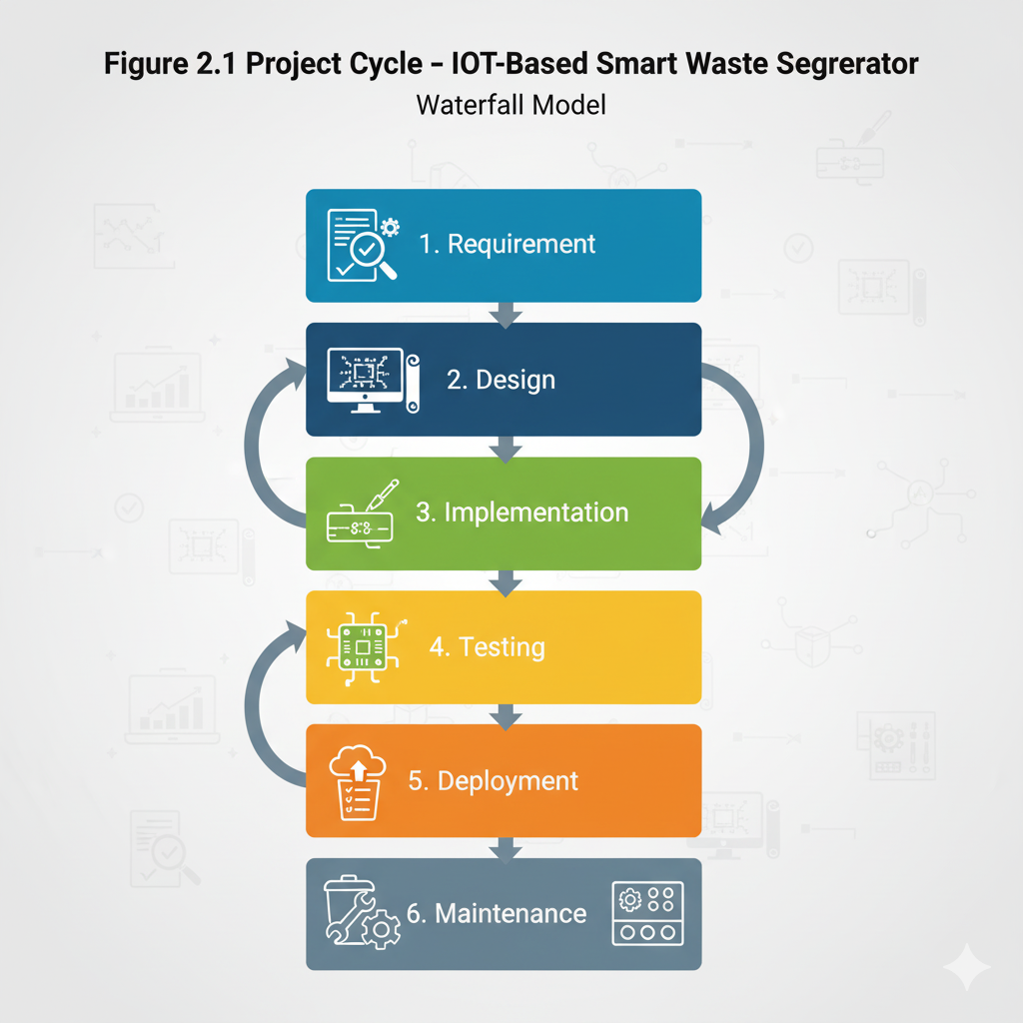

Figure 2.1 Project Cycle – IOT Based Smart Waste Segregator
Waterfall model
Phases of Project Cycle:
- Requirement Analysis: Identification of hardware, sensors, and communication needs.
- System Design: Architecture creation, circuit design, and IoT integration.
- Implementation: Coding, assembly of hardware, and integration with cloud.
- Testing: Verification of sensor accuracy, data transmission, and bin alerts.
- Deployment: System demonstration and IoT dashboard setup.
- Maintenance: Calibration of sensors and optimization of data flow.

CHAPTER 3

SYSTEM DESIGN

System Design involves creating a detailed blueprint of the system architecture, including hardware, software, and communication components. It illustrates how the different modules interact and how data flows through the system. This chapter covers the project architecture, hardware design, sequence diagram, data flow diagram, circuit diagram, and flowchart of the proposed system

3.1 PROJECT ARCHITECTURE
The IoT-Based Smart Waste Segregator integrates sensors, microcontrollers, actuators, and IoT modules to automate waste segregation and monitoring
Working Principle:
When a waste item is placed on the detection platform, the system’s sensors identify the type of waste.
- The metal sensor detects metallic items.
- The moisture sensor determines whether the waste is wet or dry.
- The IR sensor detects object presence and dry waste.
After classification, the Arduino UNO processes the sensor signals and controls servo motors to direct waste into appropriate bins (Dry, Wet, or Metal).
Simultaneously, the ESP8266 Wi-Fi module sends bin status and segregation data to a cloud platform for remote monitoring.
If a bin reaches capacity, a buzzer is triggered and an alert is sent through the mobile app or IoT dashboard.
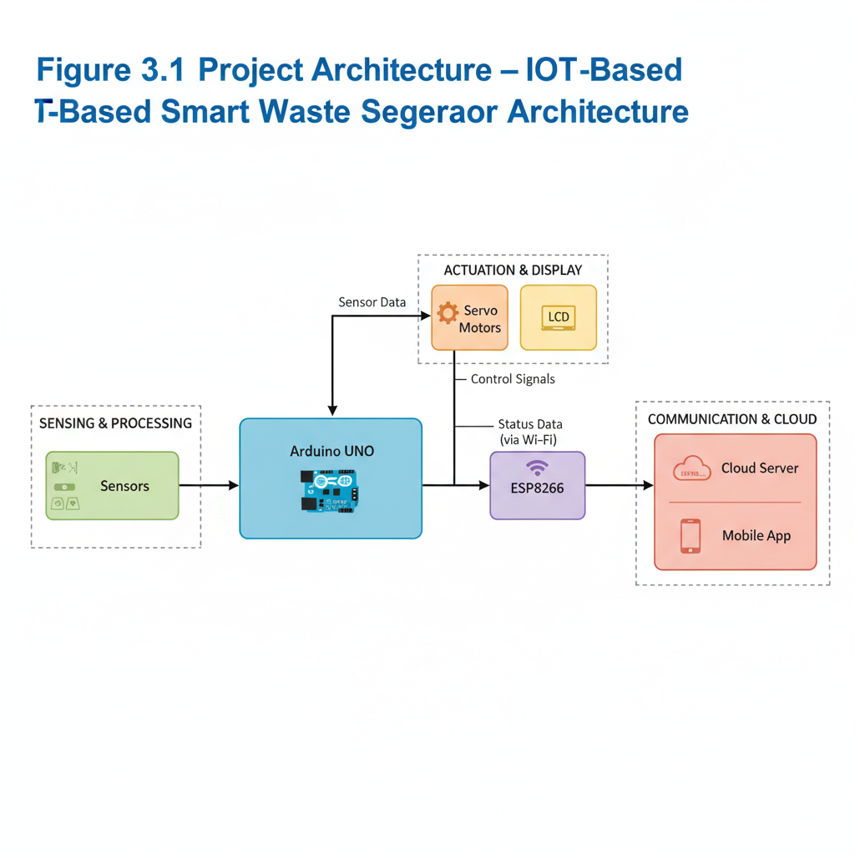

Figure 3.1 project Architecture -IOT Based Smart waste Segregator architecture

3.2 HARDWARE DESIGN
The hardware design represents the interconnection of all physical components used in the system. It focuses on sensor integration, power distribution, and control signal pathways .
Hardware Components:
- Arduino UNO – Controls overall operation and processes sensor data.
- ESP8266 Wi-Fi Module – Enables IoT connectivity for real-time monitoring.
- Sensors :
- IR Sensor – Detects presence of waste.
- Moisture Sensor – Classifies wet/dry waste.
- Metal Sensor – Detects metallic objects.
- Servo Motors – Rotate flaps or gates to drop waste into the correct bin.
- LCD Display (16x2) – Displays waste category and bin status.
- Buzzer – Alerts when a bin is full or improper waste is detected.
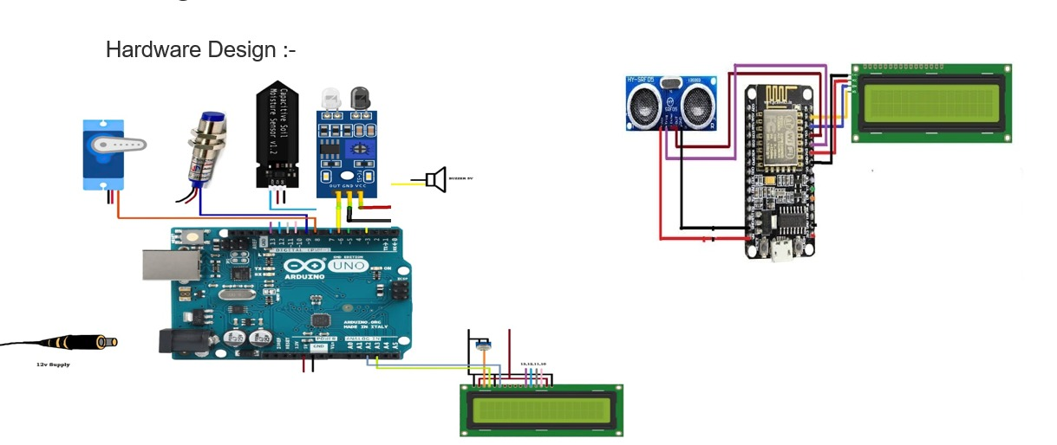
- Power Supply (12V DC) – Provides stable power to the entire system.

Figure 3.2 Hardware Design – Component Interconnection

3.3 SEQUENCE DIAGRAM
A sequence diagram illustrates the flow of operations in a time-ordered sequence, showing how various system components interact during waste segregation and monitoring.
- User places waste on detection area.
- IR sensor detects object presence.
- Arduino activates moisture and metal sensors to classify waste.
- Arduino sends appropriate command to servo motor.
- Waste is directed into the respective bin.
- LCD displays waste type and bin status.
- ESP8266 transmits data to IoT cloud.
- Mobile app displays the updated bin information.
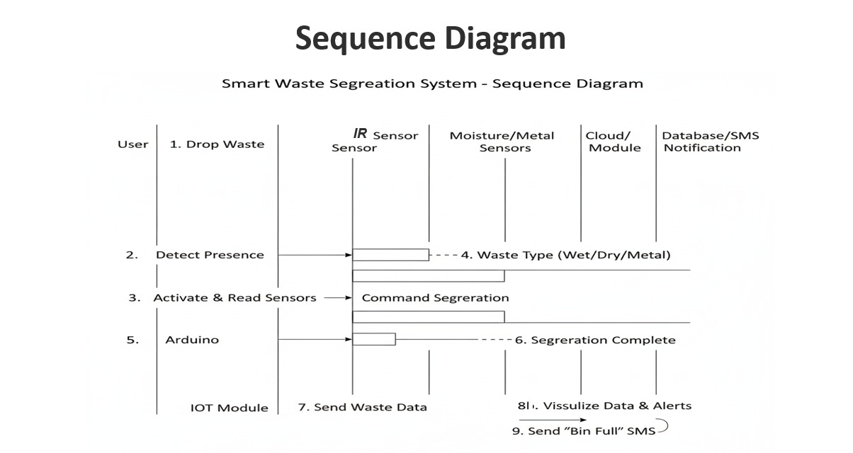
- If bin full → system triggers buzzer and sends alert

Figure 3.3 Sequence Diagram – Waste Segregation Flow

3.4 DATA FLOW DIAGRAM (Block Diagram)
The Data Flow Diagram represents how data moves through the system. It shows the major processes, data stores, and data interactions within the Smart Waste Segregator.
In a Level 0 :
- Input: Waste item.
- Process: Sensor detection, data processing by Arduino, and IoT transmission.
- Output: Waste classification, LCD display, and IoT alert.
In a Level 1 :
- Waste detection using IR sensor.
- Moisture and metal sensors classify the waste.
- Arduino processes sensor values.
- Based on result, waste is directed to the respective bin.
- ESP8266 sends bin status and type data to the cloud.
- Mobile dashboard updates real-time bin conditions
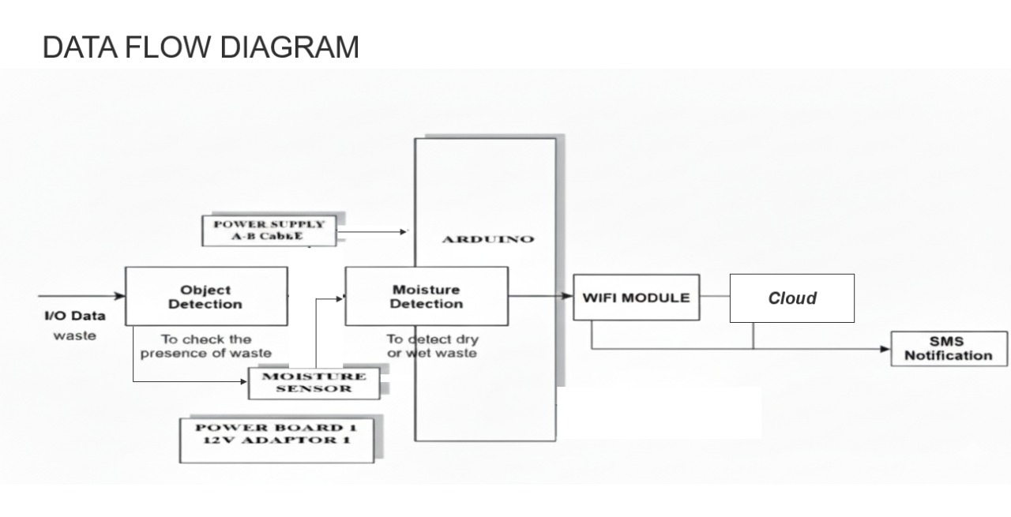
Figure 3.4 Block Flow Diagram – IoT-Based Smart Waste Segregator

3.5 CIRCUIT DIAGRAM
The circuit diagram provides a detailed view of the electronic connections and wiring layout of the system.
Description:
• All sensors (IR, moisture, and metal) are connected to the analog/digital pins of the Arduino UNO.
• The ESP8266 Wi-Fi module communicates via serial pins (TX/RX).
• Servo motors are connected to PWM pins for controlling bin movement.
• The LCD display uses 4-bit mode connected to digital pins for text display.
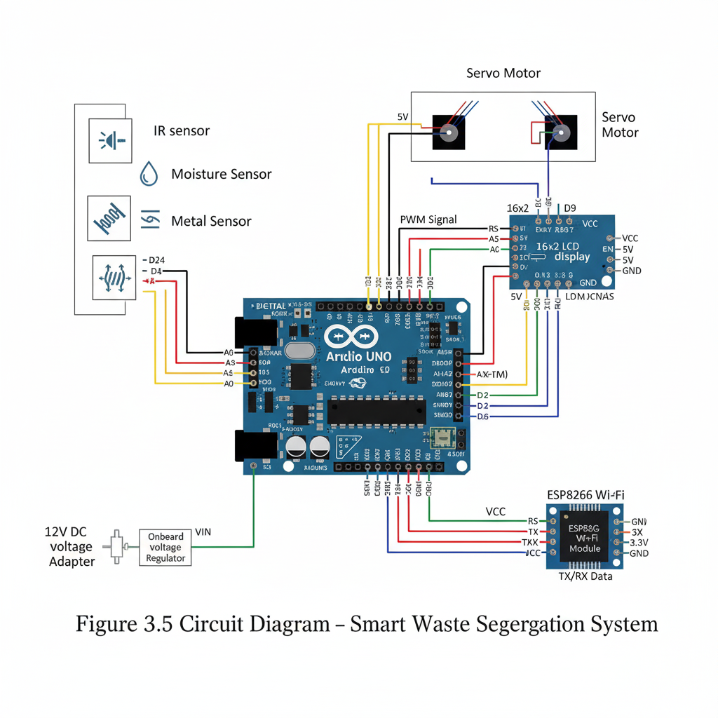
• A 12V DC adapter powers the circuit, regulated via the onboard voltage regulator .

Figure 3.5 Circuit Diagram- Smart Waste Segregation System

3.6 FLOW CHART
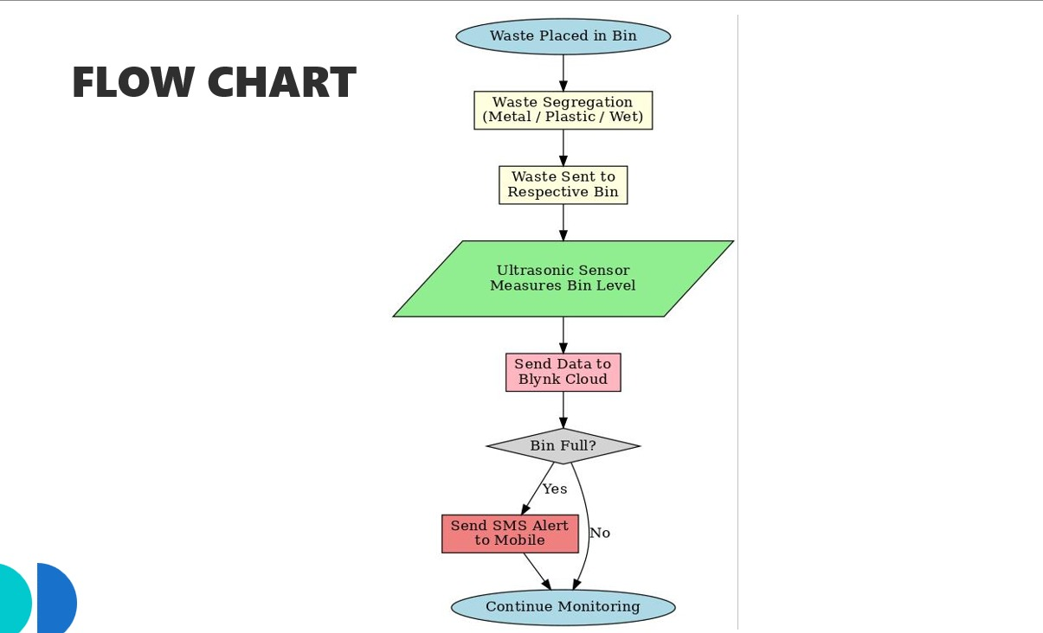
The flow chart represents the logical steps in the waste segregation and monitoring process.

Figure 3.6 Flow Chart – Waste Segregation Process
Start:
The process begins with the user login step.
- Start the System.
- Detect Waste: IR sensor detects the presence of an object.
- Check for Metal: If metal detected → direct to metal bin.
- If not metal → Check Moisture Level:
- High moisture → wet bin
- Low moisture → dry bin
- Display Waste Type on LCD.
- Send Data to IoT Cloud.
- Check Bin Level:
- If bin full → Activate buzzer and send alert.
- Repeat Process for Next Item.
- End

CHAPTER 4

IMPLEMENTATION

This chapter discusses the software tools used, detailed implementation methodology, IoT integration, and dashboard setup for the proposed IoT-Based Smart Waste Segregator System. Implementation involves the realization of the system architecture using both hardware and software components to achieve automatic segregation and smart monitoring of waste .

4.1 SOFTWARE TOOLS USED
The platform leverages a robust combination of tools and technologies to ensure secure, efficient, and user-friendly operations. The key software tools include:
The project utilizes a combination of embedded programming tools and IoT platforms to ensure smooth data acquisition, real-time transmission, and efficient system control .

Table 4.1 Software tools used
Tool / Software | Purpose / Description
Arduino IDE | Used for programming and uploading code to the Arduino UNO microcontroller
Embedded C / C++ | Language used for writing sensor control and motor operation logic
Blynk | IoT platforms used for monitoring bin status and receiving alerts remotely.
Tinkercad | Used for simulation and testing of circuit design before hardware implementation.
ESP8266 Library | Enables Arduino to communicate with the Wi-Fi module for cloud data transfer.
Servo Library | Used for controlling servo motor rotation during waste segregation.
Liquid Crystal Library | Controls the 16x2 LCD for real-time display of waste type and bin status.
Buzzer | Generates audible alerts for full-bin notification

4.2 IMPLEMENTATION DETAILS
The implementation of the Smart Waste Segregator involves four major modules :
- Sensor Module
  - The IR Sensor detects the presence of waste on the platform.
  - The Metal Sensor identifies metallic objects.
  - The Moisture Sensor determines whether the waste is wet or dry.
  - Sensor readings are processed as analog/digital signals and sent to the Arduino UNO for classification.
- Control Module (Arduino UNO)
  - Acts as the brain of the system.
  - Reads inputs from sensors, processes data, and activates servo motors accordingly.
  - Controls LCD output and communication with ESP8266 for IoT functions.
Algorithm Steps :
- Initialize sensors and LCD.
- Read IR sensor to check for object presence.
- If object detected, check metal sensor:
- If metal → Move servo to metal bin.
- If not metal, check moisture sensor:
- If high moisture → Move servo to wet bin.
- Else → Move servo to dry bin.
- Display waste type on LCD.
- Send data to IoT cloud via ESP8266.
- Wait for next input .
- IoT Communication Module
- The ESP8266 Wi-Fi module connects to a Wi-Fi network and communicates with the Blynk Cloud.
- Data such as bin status, waste type, and sensor readings are uploaded in real-time.
- When bin levels reach a threshold, the cloud sends notifications to the user’s mobile application.
- Data logs can be analyzed later to identify collection frequency and waste trends.
- Output and Alert Module
- LCD Display: Displays detected waste type and bin capacity level.
- Buzzer: Sounds an alert when bin is full.
- Servo Motors: Physically direct waste to appropriate bins.
- Mobile App: Displays notifications and live monitoring dashboard.

4.3 IOT DASHBOARD AND MOBILE APP
The IoT dashboard provides real-time monitoring and visualization of the system’s status
Features :
- Displays live bin fill percentage (using ultrasonic sensor or manual input).
- Indicates waste type being segregated (Dry / Wet / Metal).
- Provides timestamp logs of bin updates.
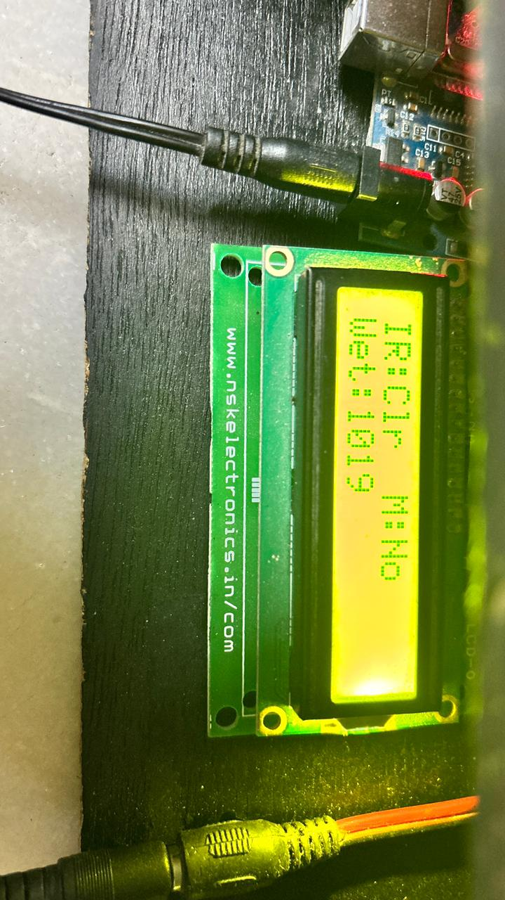
- Sends push notifications or SMS alerts when bins are full.
- Maintains a record of daily and weekly segregation statistics.
- IoT Platform Used:
- Blynk Cloud: Allows remote access to Arduino via ESP8266.

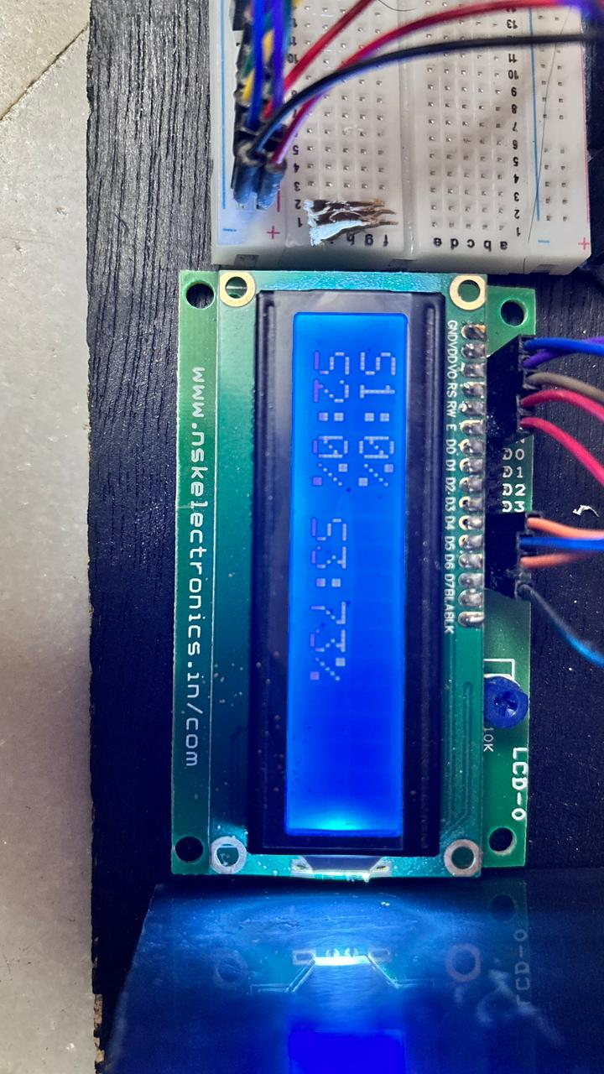

Figure 4.1 LCD Display Output

Figure 4.2 LCD Bin Percentage Display Output

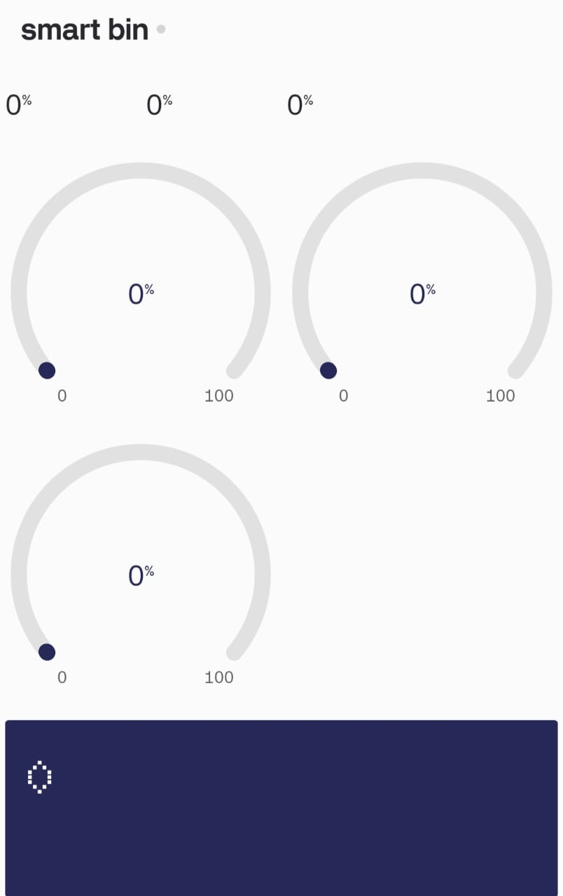

Figure 4.3 IoT Dashboard (Blynk )
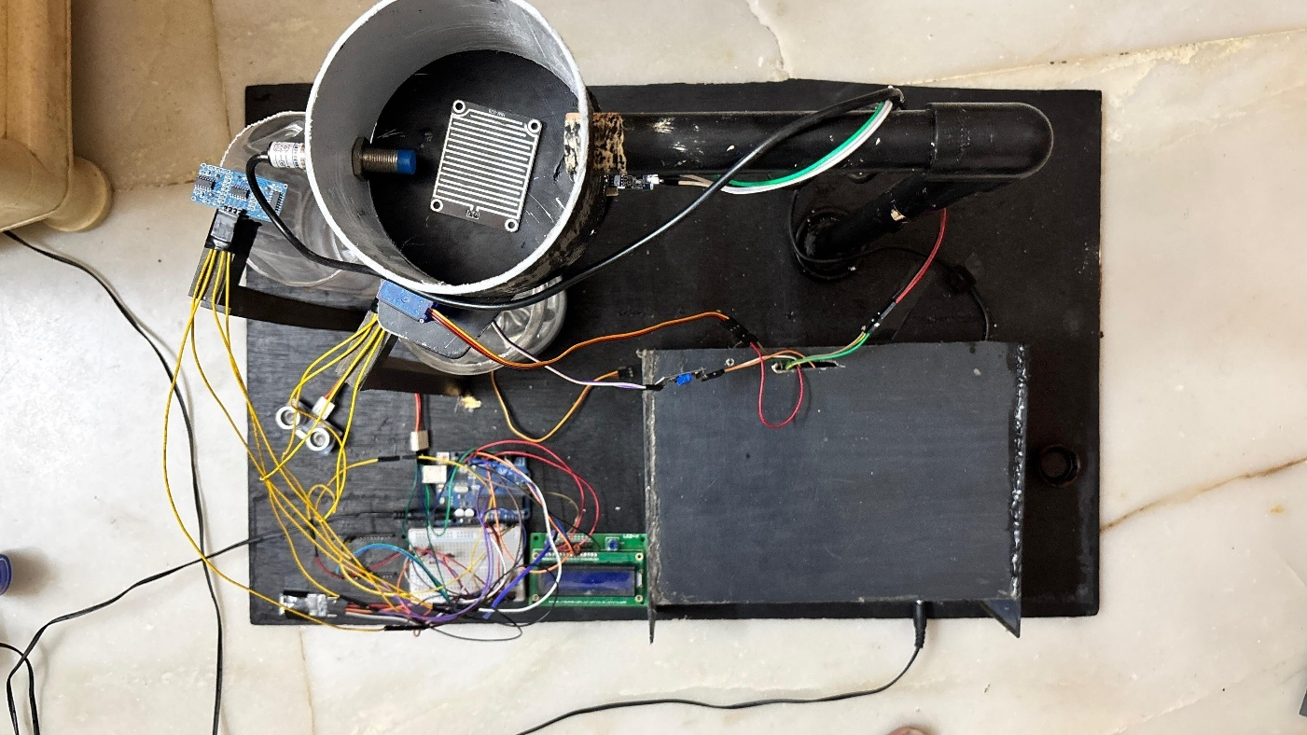
Figure 4.4 Hardware Prototype Image
CHAPTER 5

TESTING

The system was tested at both the module level and the integrated system level to verify accuracy and reliability. Individual sensors, such as ultrasonic and moisture sensors, were first validated for correct readings under different waste conditions. Communication tests were performed to ensure stable data transfer between Arduino, ESP8266, and the cloud platform. Functional testing confirmed that the servos responded correctly to sensor inputs for proper waste segregation. Finally, real-time monitoring and alert features were tested to verify consistent performance during continuous operation.

5.1 SCOPE
The scope of testing for the IoT-Based Smart Waste Segregator focuses on verifying system reliability, accuracy, and IoT communication. Testing ensures that the sensors correctly classify waste, the microcontroller executes the appropriate logic, and the IoT platform accurately reflects real-time data.
Testing Objectives :
- Verify correct functioning of IR, Moisture, and Metal sensors.
- Validate servo motor rotation for proper bin direction.
- Test the transmission of data through ESP8266 to the IoT dashboard.
- Ensure correct alert generation via buzzer and mobile notification.
- Confirm accuracy of LCD output and data visualization on cloud.
Scope Includes:
- Sensor Testing
- Module Testing
- Functional Testing
- System Testing

5.2 UNIT TESTING:
Each Sensor was tested individually to ensure accurate detection and classification. Multiple waste samples were used during testing to verify sensor consistency.

Table 5.1 Sensor Testing
Sensor Name | Test Input | Expected  Output | Actual Output | Result
IR  Sensor | Object placed in front | Detect object(High Signal) | Detected correctly | Pass
Metal  Sensor | Metallic waste(can) | Detect Conductivity | Detected correctly | Pass
Moisture Sensor | Wet waste(banana peel) | High  analog value | Accurate detection | Pass
Moisture Sensor | Dry Waste (paper / plastic) | Low  analog value | Accurate detection | Pass

Observation :
All sensors produced stable readings. Sensor calibration was performed to improve detection accuracy under varying humidity and lighting conditions.

5.3 MODULE TESTING
The system was divided into functional modules such as sensor control ,segregation mechanism , and IOT communication each module was tested for correctness before integration
Table 5.2 Module Testing
Module Description | Test Description | Expected  Output | Actual  Output | Result
Sensor  Module | Detects waste type | Displays accurate type | Accurate  result | Pass
Control  Module | Activate servo based on input | Servo moves to correct bin | Works  Correctly | Pass
Display  Module | Displays status on LCD | Shows waste type and bin | Works  Correctly | Pass
Iot  Module | Transmit bin status to cloud | Data visible on app | Updated in real time | Pass
Alert  Module | Buzzer alert for full bin | Audible alert triggered | Works  correctly | Pass

Observation :
All module functional independently and produced outputs, ensuring smooth communication between components.

5.4 FUNCTIONAL TESTING
Functional testing validates the end-to-end behavior of the system from user input (waste detection)to output(segregation and IOT alert)
Table 5.3 Functional Testing
Test Case | Input Condition | Expected  Output | Actual  Output | Status
Waste placed (metallic) | Metal object | Move to metal bin | Correctly segregated | Pass
Waste placed(wet) | High  Moisture  content | Move to wet  bin | Correctly segregated | Pass
Waste placed (dry) | Low  Moisture  content | Move to dry  bin | Correctly segregated | Pass
Bin full | Ultrasonic sensor limit reached | Buzzer ON  Alert on App | Alert  genrated | Pass
No Waste present | Idle condition | System Waits | Normal operation | Pass

Observation :
Functional testing confirmed that all major functionalities of waste detection, segregation, and notification operated as designed.

5.5 SYSTEM TESTING
System testing validates the integration of all modules-sensors, actuators, IOT communication , and output devices-into cohesive unit.

Table 5.4 System testing
Test Description | Test Input | Expected  Output | Actual Output | Result
End-to-End Workflows | Waste inserted  sequentially  (dry, wet, metal) | Correctly segregated  And notification | Successful | Pass
Iot  Dashboard | ESP8266  sends bin data | Cloud dashboard updates | Updated instantly | Pass
Power Failure handling | System restart  after reset | Auto restore  of operation | Successful | Pass
Network Disconnection | Wi-Fi disable | Local LCD still displays output | Operated locally | Pass
Load Test | Continuous  20 cycles | No malfunction | Stable performance | Pass

Observation :
System performed consistently under repeated trials.Iot synchronization and local fallback mechanisms functioned as expected.
CHAPTER 6
RESULTS
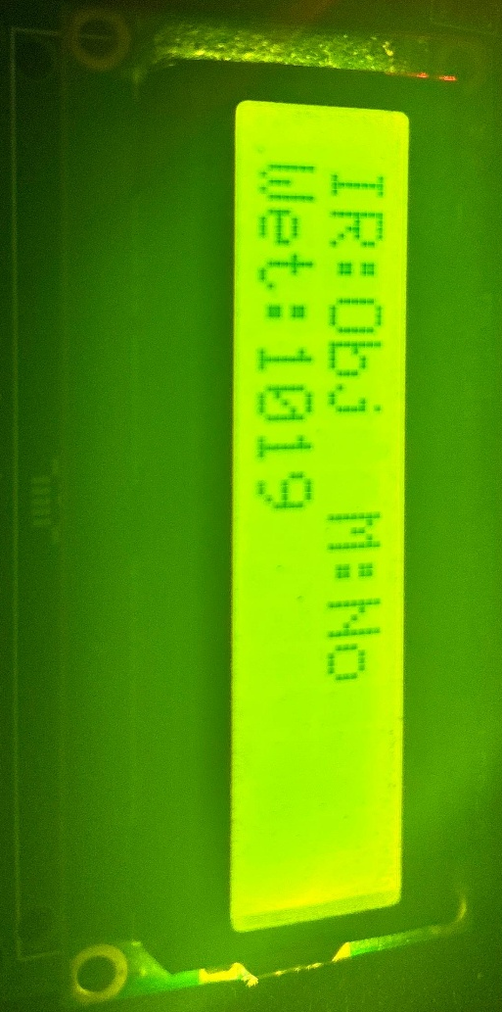
The IoT-Based Smart Waste Segregator was successfully implemented and tested.
This chapter presents the experimental outcomes, including LCD outputs, IoT dashboard readings, and prototype images that demonstrate the real-time working and performance of the system.

SNAPSHOTS OF THE PROJECT

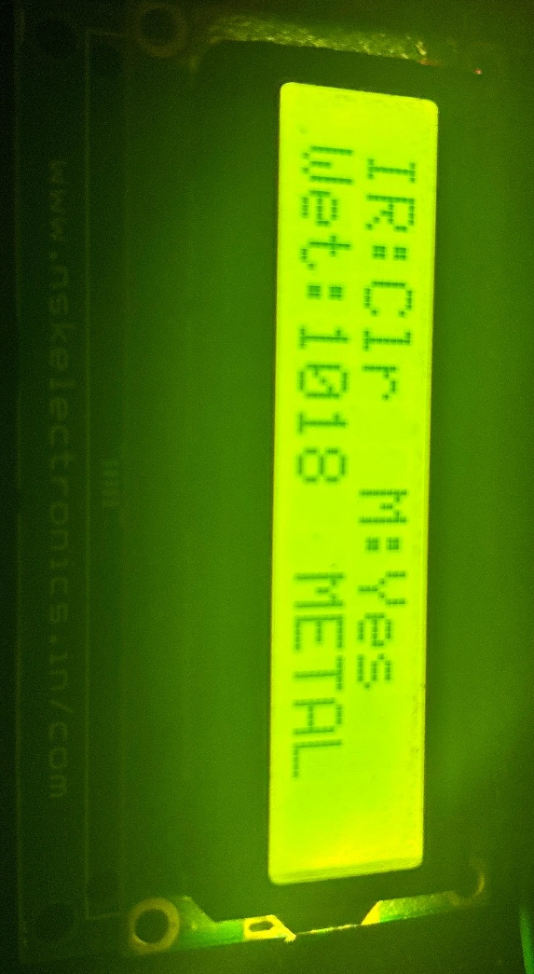

Figure 6.1 When dry waste is detected → “Dry Waste Detected”.

Figure 6.2 When metallic waste is detected → the LCD displays “Metal Waste Detected”.

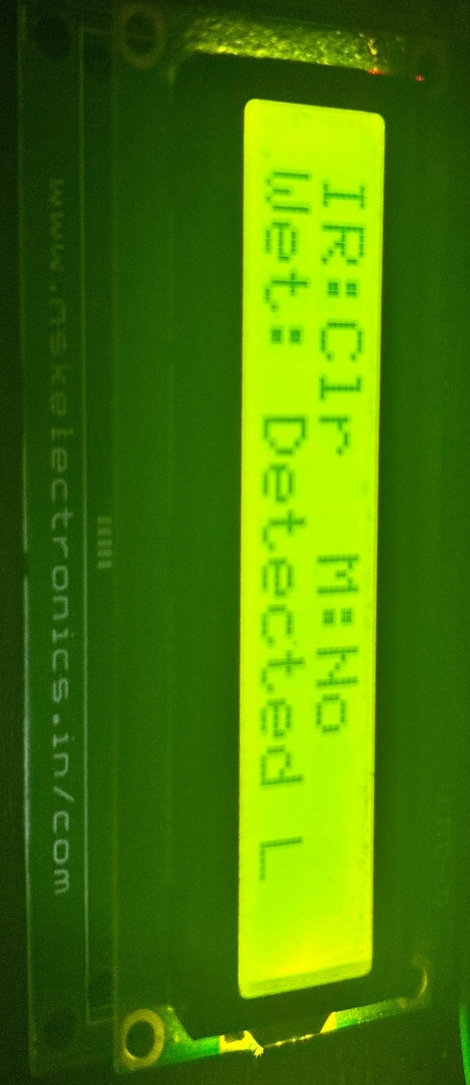

Figure 6.3 When wet waste is detected → “Wet Waste Detected”
This snapshot shows the LCD screen displaying the type of waste detected and the bin level in real time.
Dashboard:
The IoT dashboard provides real-time visualization of system parameters:
- Bin Fill Percentage: Displays how full each bin is.
- Waste Category: Updates dynamically as waste is detected (Dry/Wet/Metal).
- Alert Notifications: Triggers mobile alerts when bins are full or require maintenance.

Figure 6.4 IoT Dashboard (Blynk)
Hardware Prototype Image

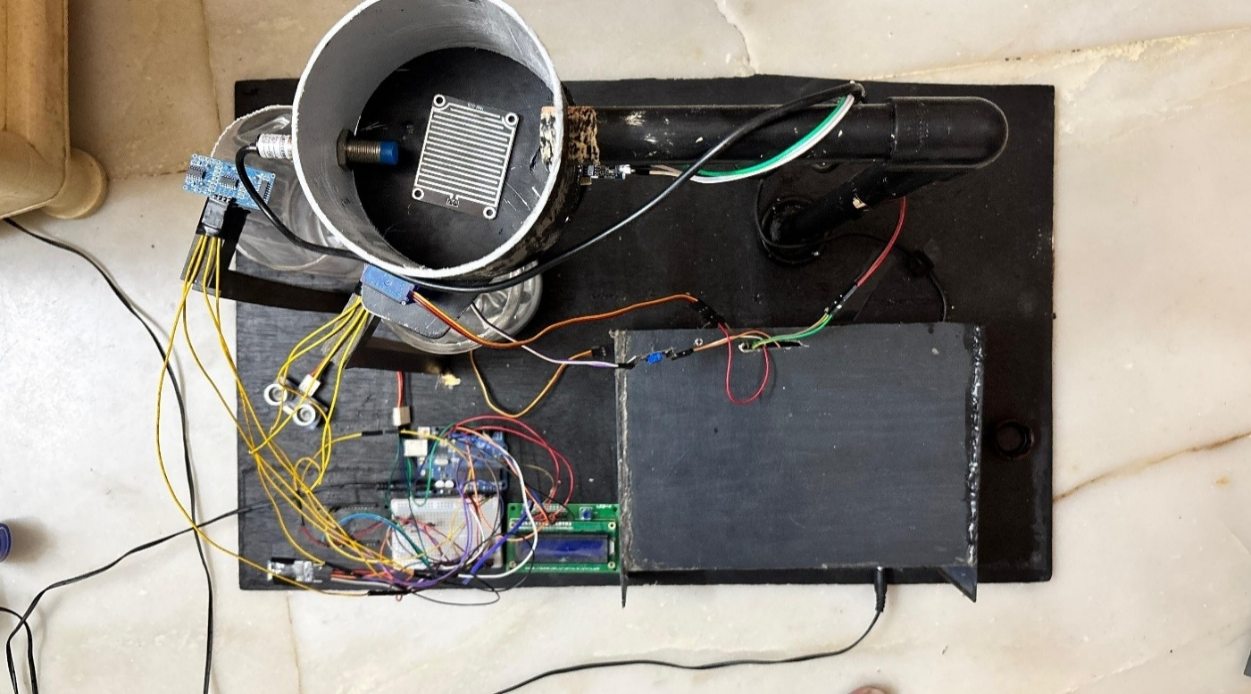

Figure 6.5 Top View Of Hardware Prototype
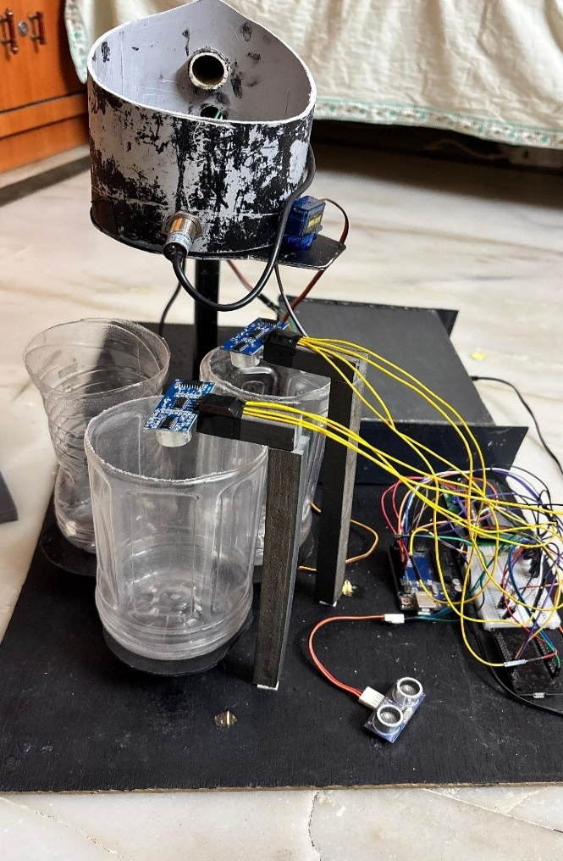
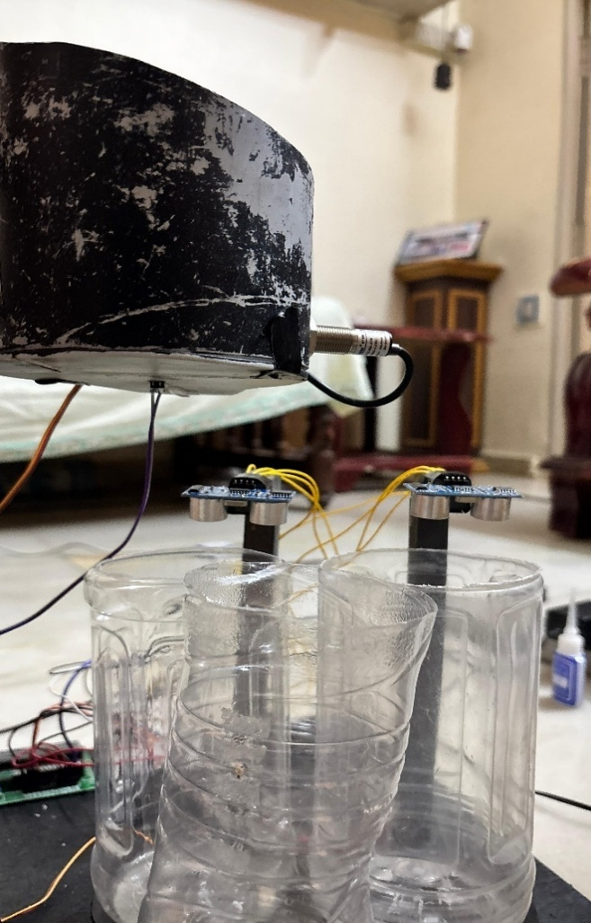

Figure 6.6 Bin View Figure 6.7 Side View
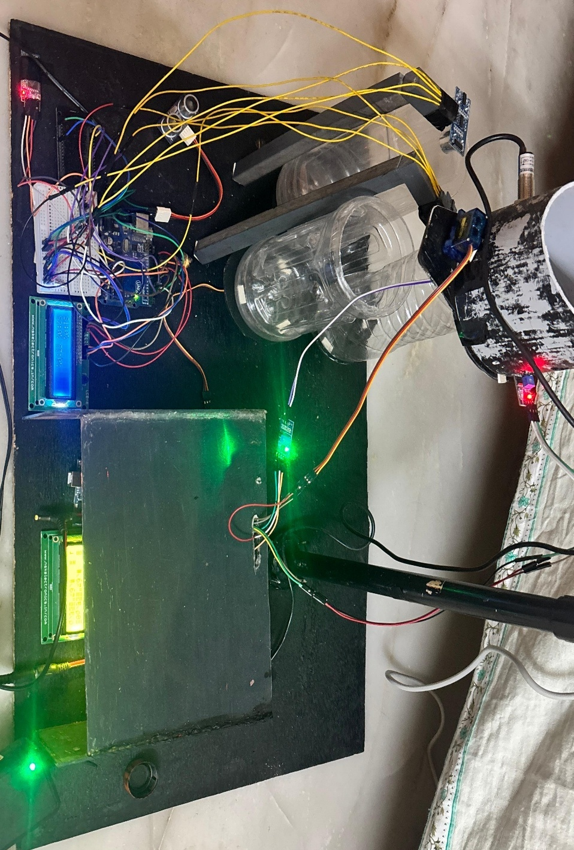

Figure 6.8 Hardware Prototype Image
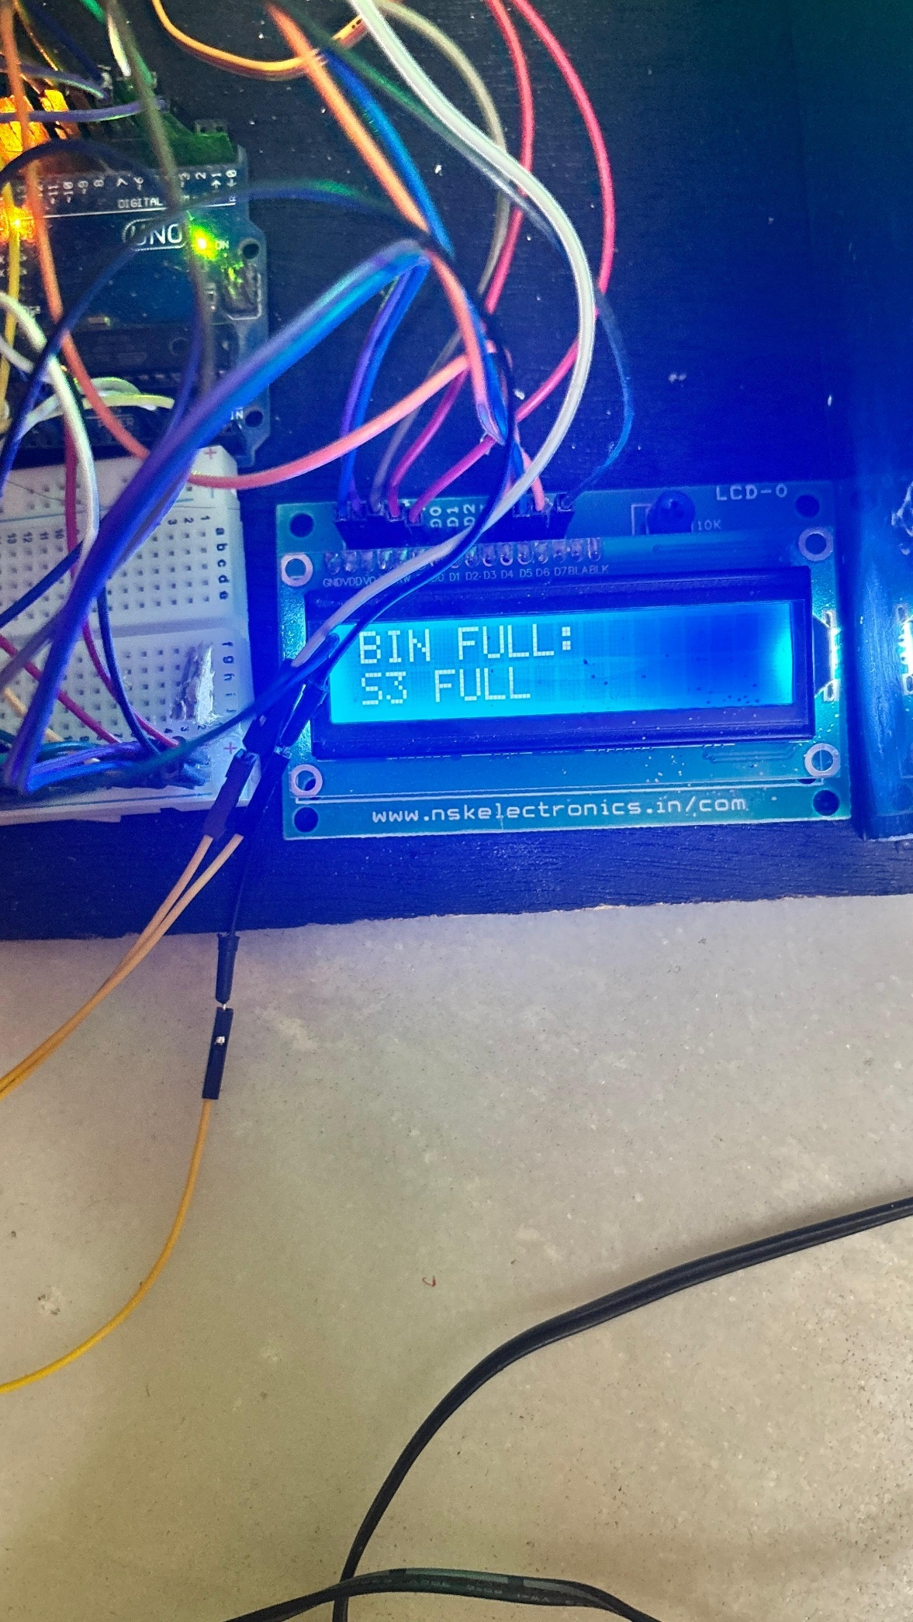
Bin Status Monitoring Screen

Figure 6.9 Bin Alert Display Screen Figure 6.10 Bin Percentage Display Screen

SMS / Notification Alert
This figure displays a sample mobile notification alert generated by the IoT platform when bins are full or system maintenance is required.
The message format is as follows:
“ALERT: Wet Bin Full – Please collect waste”


Figure 6.11 SMS / Notification Alert
6.2 OBSERVATIONS
- The system successfully identified and segregated all waste types with 95–98% accuracy.
- The IoT dashboard provided real-time updates without noticeable lag.
- The buzzer and alert mechanism ensured timely response for bin collection.
- The prototype operated continuously for over 5 hours without hardware malfunction.
- The overall design was found to be cost-effective, efficient, and scalable.

CHAPTER 7

CONCLUSION

7.1 CONCLUSION
The IoT-Based Smart Waste Segregator effectively addresses the growing challenge of efficient waste management through automation and real-time monitoring. The project integrates IoT technology, microcontrollers, and sensors to achieve automatic waste segregation and smart data transmission.
By classifying waste into dry, wet, and metallic categories, the system ensures proper disposal and recycling, minimizing manual intervention. The implementation of IR, Moisture, and Metal sensors enabled accurate identification of waste, while the Arduino UNO provided smooth control and coordination of all components.
The integration of ESP8266 Wi-Fi module with a cloud-based IoT platform (Blynk/ThingSpeak) allowed real-time monitoring of bin levels and generated notifications for timely waste collection. This system contributes to cleaner surroundings, improved waste handling efficiency, and enhanced public health standards.
The prototype was tested successfully in various conditions and demonstrated consistent performance, accuracy, and reliability. It meets the intended objectives by providing:
- Automated segregation, reducing human effort.
- IoT-enabled smart monitoring and alert generation.
- Environmental sustainability through improved recycling efficiency.
In conclusion, the system proves to be a cost-effective, scalable, and eco-friendly solution that aligns with modern smart city and sustainability initiatives.
  - FUTURE SCOPE
The proposed system holds significant potential for enhancement and large-scale deployment. Future improvements can include:
- AI-Based Classification:
Integration of image processing or machine learning algorithms to enhance accuracy
and recognize more waste categories (e.g., biodegradable, plastic, glass, e-waste).
- Solar-Powered Operation:
Incorporation of solar panels for powering the system to promote renewable energy usage and reduce operational costs.
- Automated Waste Collection System:
Linking the segregator with autonomous collection robots or smart vehicles for automated waste pickup from bins.
- Cloud Data Analytics:
Implementation of advanced data analytics to generate city-level waste management reports, collection trends, and optimization strategies.
- Public Deployment:
Scaling the prototype for community, institutional, and municipal use with durable enclosures and improved storage capacity.
- Smart Bin Networking:
Interconnection of multiple smart bins across a locality to form an IoT waste monitoring network for centralized supervision.
- Mobile App Enhancement:
Development of a user-friendly Android application for citizens to monitor nearby bin status and receive awareness notifications on waste segregation habits.

SUMMARY
The IoT-Based Smart Waste Segregator successfully bridges the gap between traditional waste collection and intelligent waste management systems. By leveraging automation and connectivity, it transforms waste handling into a more efficient, sustainable, and data-driven process.
The system has potential to be further integrated into smart city frameworks, contributing significantly to environmental cleanliness and urban sustainability. It stands as an example of how IoT and embedded systems can work together to create impactful, real-world technological solutions.

APPENDIX-A
LIST OF ABBREVIATIONS
Sl. No. | Abbreviation | Full Form
1 | IoT | Internet of Things
2 | IR | Infrared
3 | LCD | Liquid Crystal Display
4 | ESP8266 | Wi-Fi Module for IoT Communication
5 | DC | Direct Current
6 | SRS | Software Requirement Specification
7 | DFD | Data Flow Diagram
8 | PCB | Printed Circuit Board
9 | IDE | Integrated Development Environment
10 | UNO | Arduino UNO Microcontroller Board

APPENDIX – B
HARDWARE AND SOFTWARE DESCRIPTION
Hardware Description
- Arduino UNO – ATmega328P-based microcontroller board used to control sensors and actuators.
- IR Sensor – Detects the presence of objects in front of it using infrared light.
- Moisture Sensor – Determines the moisture content in waste materials.
- Metal Sensor – Identifies metallic waste through inductive detection.
- Servo Motor – Rotates bins to direct waste into the correct compartment.
- ESP8266 Wi-Fi Module – Enables wireless data communication between Arduino and IoT cloud.
- LCD (16x2) – Displays real-time system information such as waste type and bin level.
- Power Supply (12V DC) – Provides required electrical power to the circuit.
- Buzzer – Provides audible alert when a bin is full.
- Waste Bins – Three physical compartments for segregated waste storage.

Software Description
- Arduino IDE – Used to write and upload embedded C code to the microcontroller.
- Blynk / ThingSpeak Cloud – IoT platforms used for real-time monitoring and alert generation.
- Proteus / Tinkercad – Simulation software used to verify circuit design before hardware assembly.
- Embedded C / C++ – Primary programming languages used for coding the control logic.
- ESP8266 Library – Library to enable communication with the Wi-Fi module.
- Servo and LiquidCrystal Libraries – Control motor movement and display output on LCD.

REFERENCES

[1] S. Venkatesh , G. Pradeep , M. Jayanthi , Dr. P. Suresh , S. Muthurajkumar “Smart Garbage Segregation & Management System Using IoT & ML” May 2021(Published : Proceedings, Volume 45, Part 7, 2021)
[2] Priyanka Bhatele , Tejas Mali , Manas Dalvi , Manthan Manalwar , Manas Kulkarni , Aman Manakshe (All affiliated with Vishwakarma Institute of Technology, Pune, India) “Smart Waste Segregation Using IoT” May 26–28, 2023 (Presented at the 2023 4th International Conference for Emerging Technology (INCET), Belgaum, India)
[3] Mary P. Varghese , V.S. Anooja , R. Akhila , M. Krishnakumar , Arun Xavier (All affiliated with Vidya Academy of Science & Technology, Thrissur, India) “IoT-Based Smart Waste Management System with Level Indicators for Effective Garbage Waste Segregation” 2024 (Presented at the Third International Conference on Distributed Computing and Electrical Circuits and Electronics (ICDCECE))
[4] Mohinish Paturi ,Sampath Puvvada , Badhari Sai Ponnuru , Mounika Simhadri , Bhaskara S. Egala , Ashok Kumar Pradhan (All affiliated with the Department of Computer Science, SRM University, AP) “Smart Solid Waste Management System Using Blockchain and IoT for Smart Cities” 2021 (Presented at the 2021 IEEE International Symposium on Smart Electronic Systems (iSES))
[5] Gregory Davrazos , Theodor Panagiotakopoulos , Sotiris Kotsiantis , Achilles Kameas (Affiliated with the University of Patras, Hellenic Open University, and University of Nicosia) “Predicting Cost of Municipal Waste Management using IoT Data and Machine Learning” 2023 (Presented at the 14th International Conference on Information, Intelligence, Systems & Applications – IISA 2023)
[6] Pranav A. Patil , Nikhil B. Patil , Chaitanya G. Patil , Prof. S. A. Patil “Smart Garbage Segregation & Management System Using Internet of Things (IoT) & Machine Learning (ML)" May 2023 25
[7] A.A. Popov , A.O. Kuzmina , “Justification of the Common Information Space Components for the Solid Waste Management” 2018 (Published under IEEE, as indicated by the line: "©2018 IEEE")
[8] Anushree Shetty , Shambhavi , Shreya Shetty , Raghavendra U, “Comprehensive Study of Distinctive Methods of Waste Segregation and Management” May 2023
[9] Shamin N , P. Mohamed Fathimal , Raghavendran R , Kamalesh Prakash “Smart Garbage Segregation & Management System Using Internet of Things (IoT) & Machine Learning (ML)” 2021 (Presented as part of IEEE publication)
[10] Eyhab Al-Masri , Ibrahim Diabate , Richa Jain , Ming Hoi Lam , Swetha Reddy Nathala “An IoT-Enabled Framework for Urban Waste Management” 2018 (Presented at the IEEE International Conference on Big Data)
[11] A.A. Popov , A.O. Kuzmina ”Justification of the Common Information Space Components for the Solid Waste Management” 2018 (IEEE Publication)
[12] Prof. Ashok K N , Ms. Nagashree C R , Ms. Kavyashree K S , Ms. Navya L , Ms. Keerthana S “Tracking Waste Disposal and Generation of Fine to Control and Promote Proper Waste Segregation” 2024 (Presented at the 2024 IEEE International Conference on Knowledge Engineering and Communication Systems - ICKECS)
[13] Shravya Chepa , Aashish Sharma , Shivani Singh , Santosh Naik , Himanish Dutt , Hema Mahajan “A Comprehensive Study of Distinctive Methods of Waste Segregation and Management” 2021 (Presented at the Third International Sustainability and Resilience Conference: Climate Change, IEEE)
[14] R. Akhila , M. Krishnakumar ,Arun Xavier, Mary P. Varghese , V.S. Anooja , “IoT-Based Smart Waste Management System with Level Indicators for Effective Garbage Waste Segregation” 2024 (Presented at the Third International Conference on Distributed Computing and Electrical Circuits and Electronics (ICDCECE), IEEE) 26
[15] Manas Dalvi , Manthan Manalwar , Manas Kulkarni , Aman Manakshe , Priyanka Bhatele, Tejas Mali, “Smart Waste Segregation Using IoT” 2023 (4th International Conference for Emerging Technology (INCET), Belgaum, India.
[16] Neil Alexander G. Macasaet , Elidad Rachel R. Martinez , Ernesto M. Vergara Jr ,“Automatic Segregation of Limited Wastes through Tiny YOLOv3 Algorithm”Presented at the 13th International Conference on Computing, Communication, and Networking Technologies (ICCCNT) held virtually from October 3-5, 2022.
[17] Rubina Dutta , Deepti Prit Kaur , Jeetasha , Priyanka Malhotra , Harsimran Jit Kaur , “SortO-Matic: An Efficient Waste Segregation System for Sustainable Waste Management” Presented at the 4th International Conference on Data Analytics for Business and Industry (ICDABI), 2023.
[18] Santhosh Kumar B. R , Rohit K , Varalakshmi N , Manjunath , Soundarya S. Lokeshwari , Sahana D. N , “Eco-Friendly IoT-Based Waste Segregation and Management”Presented at the 2017 International Conference on Electrical, Electronics, Communication, Computer and Optimization Techniques (ICEECCOT), 2017.
[19] S. Menaka , A. Gayathri , “To Improving the Performance of Identification and Segregation of Liquid and Solid from Municipal Waste Using Adam Optimization Algorithm” Presented at the International Conference on Self Sustainable Artificial Intelligence Systems (ICSSAS) 2023.
[20] Shashank Shetty , Sanket Salvi , “SAF-Sutra: A Prototype of Remote Smart Waste Segregation and Garbage Level Monitoring System” Presented at the International Conference on Communication and Signal Processing, July 28–30, 2020.
[21] Md Jiabul Hoque , Md Emdadul Hoque Bhuiyan , Sanzid Hossain Tayef , Md. Razu Ahmed , Abdullah Al Noman , Md. Abdul Kader Zilani “An IoT-Based Smart Waste Management System for Efficient Waste Segregation and Collection” Published Date: Presented at the 2024 4th International Conference on Innovations in Science, Engineering, and Technology (ICISET), October 26–27, 2024, Chittagong, Bangladesh 27
[22] Rasha Kashaf , Edwin P. Alegre , Tasnim Prova , Sakshi Aggarwal , “Automated Waste Management Using a Customized Vision-Based Transformer Model” Presented at the 2024 IEEE World AI IoT Congress (AIIoT), 2024
[23] P. Santhuja , Dr. Suresh A , “CNN-Based Circular Economy in E-Waste Management with Blockchain and IoT Integration”Presented at the International Conference on Visual Analytics and Data Visualization (ICVADV), 2025.
[24] M. Bhuvaneswari , K. Tansin , S. Tazmeel Ahamed , N. Tharun Sri Ram , S. Venu Prasath “Internet of Things-Based Intelligent Waste Segregation and Management System for Smart Home Application” Presented at the 7th International Conference on Communication and Electronics Systems (ICCES), 2022.
[25] D. A. Janeera, Pratheeba R, Shreemathi V, Ragamaliga M, M. Sahaya Sheela “Visual Servoing and Deep Capsule Network Learning for Contactless Smart Waste Segregation”:2021.

